# 

**GGC Library Management System**

**By**

**Muhammad Shahzaib Afzal**

**Nouman Aziz**

**Mehran Ali**

**DERGREE**

**BS Information Technology**



**Department / Degree of Computing & Information Technology**

**University of Gujrat**

**Session**

**2019-23**

**ACKNOWLEDGEMENT**

We pay our Gratitude to our supervisor **Miss Faiza Rasheed** for providing us with the opportunity to work in the respective direction. We are also grateful to the principal. We can never forget out teachers since we started going to school. Every teacher at every step of our lives was a hand in building academically as well as morally.

May Allah guide us righteous path, provide us the strength to fulfill our duties towards Him and His creation, help us to be thankful for what He has destined for us, enable us to be firm with our morals and humanity and enlist us among those He is pleased with. (AMEEN)

|  |  |  |
| --- | --- | --- |
| **Nouman Aziz** | **Muhammad Shahzaib Afzal** | **Mehran Ali** |
| **19721556-046** | **19721556-017** | **19821556-002** |
|  |  |  |

**DEDICATION**

This project is dedicated to our parents whose love, prayers, hopes and encouragements have always been there behind every bit of our success.

We also dedicate this dissertation to our many Teachers. We will always appreciate all they have done, especially **Miss Faiza Rasheed** for helping us develop our technology skills and for helping us to master the leader dots.

|  |  |  |
| --- | --- | --- |
| **Nouman Aziz** | **Muhammad Shahzaib Afzal** | **Mehran Ali** |
| **19721556-046** | **19721556-017** | **19821556-002** |
|  |  |  |

**DECLARATION**

We, Nouman Aziz S/O Abdul Aziz Roll No. 19721556-046, Muhammad Shahzaib Afzal S/O Muhammad Afzal Roll No. 19721556-017, Mehran Ali S/O Ishtiaq Hussain Roll N0. 19821556-002, students of BS (Information Technology), Department of Information Technology, Govt. Graduate College Jhelum Pakistan, hereby to declare that the data quoted in this Project titled “Govt Graduate College Library Management System” is based on my original work and has not yet been submitted or published elsewhere.

**Muhammad Shahzaib Afzal**

**Nouman Aziz**

**Mehran Ali**

I certify that Muhammad Shahzaib Afzal Roll 19721556-017, Nouman Aziz Roll 19721556-046, Mehran Ali Roll 19821556-002, students of Bachelor of Information Technology, Department of Computing & Information Technology, University Of Gujrat Pakistan, worked under my supervision and the above stated declaration is true to the best of my knowledge.

**Miss Faiza Rasheed (Supervisor)**

Department of Information Technology

Govt. Postgraduate College Jhelum

Email: supervisoremail

Dated:

**PROJECT COMPLETION** **CERTIFICATE**

It is verified that this report titled “GGC Library Management System” we certify that Nouman Aziz S/O Abdul Aziz Roll No. 19721556-046, Muhammad Shahzaib Afzal S/O Muhammad Afzal Roll No. 19721556-01, Mehran Ali S/O Ishtiaq Hussain Roll N0. 19821556-001, Students of Bachelor of Science (Information Technology), Department of Computing and Information Technology, University of Gujrat, Pakistan, contains sufficient material required for the award of above said degree.

**Miss Faiza Rasheed (Supervisor)**

Department of Information Technology

Govt. Graduate College Jhelum

Email: supervisioremail

Dated:

**Mr. Ikram-ul-Haq (Head of IT Department)**

Department of Information Technology Govt. Postgraduate College Jhelum

Email: hodemail

Dated:

**Table of Content**

Contents

INTRODUCTION 1

1.1. Introduction 2

1.2 Background and Existing System 2

1.3 Problems in Existing System 2

1.4 Proposed System 3

1.5 Main Modules 3

1.6 Expected Outcome 5

1.7 Tools & Technology: 5

1.8 Activity Index 6

REQUIREMENT ANALYSIS 7

2.1 Requirement Analysis 8

2.2 Functional Requirements 8

2.3 Non-Functional Requirements 10

2.4 Use Cases 10

DESIGN 41

3.1 DESIGN 42

3.2 Class Diagram 42

3.3 Sequence Diagram 43

3.4 Collaboration Diagram 54

TESTING 64

4.1 Testing 65

CONCLUSION & FUTUREWOR 80

5.1 Future Work: 81

5.2 Conclusion: 82

USER MANUAL 83

84

85

REFERENCES 101

**LIST OF FIGURES**

**FIGURES PAGE**

Figure 1: Use Case Diagram of Administrator Login 30

Figure 2: Use Case Diagram of Administrator Logout 31

Figure 3: Use Case Diagram of Administrator Forget Password 31

Figure 4: Use Case Diagram of User Sign up 32

Figure 5: Use Case Diagram of User Login 32

Figure 6: Use Case Diagram of User Logout 33

Figure 7: Use Case Diagram of User Forget Password 33

Figure 8: Use Case Diagram of Administrator Manage Students 34

Figure 9: Use Case Diagram of Administrator Manage Staff 34

Figure 10: Use Case Diagram of Administrator Manage Books 35

Figure 11: Use Case Diagram of Administrator View Details 35

Figure 12: Use Case Diagram of Administrator Generate Report 36

Figure 12: Use Case Diagram of User Search Book 36

Figure 13: Use Case Diagram of User View Book Details 37

Figure 14: Use Case Diagram of User Reserve Book 37

Figure 14: Use Case Diagram of Admin Issue Book 38

Figure 15: Use Case Diagram of User Renew Book 38

Figure 16: Use Case Diagram of User Read eBook 39

Figure 17: Use Case Diagram of User Clearance Form 39

Figure 18: Use Case Diagram of Edit Profile 40

Figure 18: Class Diagram for Library Management System 42

Figure 19: Sequence Diagram of Administrator Login 43

Figure 20: Sequence Diagram of Administrator Logout 44

Figure 21: Sequence Diagram of Administrator change password 44

Figure 22: Sequence Diagram of Manage User 45

Figure 23: Sequence Diagram of Manage Book 45

Figure 24: Sequence Diagram of Manage Category 46

Figure 25: Sequence Diagram of Manage Department 46

Figure 26: Sequence Diagram of View Details 47

Figure 27: Sequence Diagram of Generate Report 47

Figure 28: Sequence Diagram of Issue Book 48

Figure 29: Sequence Diagram of User Login 48

Figure 30: Sequence Diagram of User Logout 49

Figure 31: Sequence Diagram of Change Password 49

Figure 32: Sequence Diagram of Search Book 50

Figure 33: Sequence Diagram of User View Details 50

Figure 34: Sequence Diagram of Reserve Book 51

Figure 35: Sequence Diagram of Edit Profile 51

Figure 36: Sequence Diagram of Renew Book 52

Figure 37: Sequence Diagram of Clearance Form 53

Figure 38: Collaboration Diagram of Administrator Login 54

Figure 39: Collaboration Diagram of Administrator Logout 55

Figure 40: Collaboration Diagram of Administrator change password 55

Figure 41: Collaboration Diagram of Manage User 56

Figure 42: Collaboration Diagram of Manage Book 56

Figure 43: Collaboration Diagram of Manage Category 57

Figure 44: Collaboration Diagram of Manage Department 57

Figure 45: Collaboration Diagram of Issue Book 58

Figure 46: Collaboration Diagram of Generate Report 58

Figure 47: Collaboration Diagram of User Login 59

Figure 48: Collaboration Diagram of User Logout 59

Figure 49: Collaboration Diagram of Change Password 60

Figure 49: Collaboration Diagram of User Search Book 60

Figure 50: Collaboration Diagram of Search Book 60

Figure 51: Collaboration Diagram of View Details 61

Figure 52: Collaboration Diagram of Renew Book 61

Figure 53: Collaboration Diagram of Read E-Book 62

Figure 54: Collaboration Diagram of Clearance Form 62

Figure 55: Collaboration Diagram of Edit Profile 63

**LIST OF TABLE**

**TABLES PAGE**

Table 1: UC_01 Administrator Login 11

Table 2: UC_02 Administrator Logout 12

Table 3: UC_03 Administrator Change Password 13

Table 4: UC_04 Users Signup 14

Table 5: UC_05 Student Management 15

Table 6: UC_06 Faculty Staff Management 16

Table 7: UC_07 Books Management 17

Table 8: UC_08 Generate Reports 18

Table 9: UC_09 User Login 19

Table 10: UC_10 User Logout 20

Table 11: UC_11 User Change Password 21

Table 12: UC_12 Search Books 22

Table 13: UC_13 View Book Details 23

Table 14: UC_14 Reserve Books 24

Table 15: UC_15 Issue Books 25

Table 16: UC_16 Renew Books 26

Table 17: UC_17 Read eBooks 27

Table 18: UC_18 Fill Clearance Form 28

Table 19:UC_19 Edit Profile 29

Table 20: Testing Admin Login 65

Table 21: Testing Admin Logout 66

Table 22 :Testing Admin Change Password 67

Table 23: Testing Manage Students 68

Table 24: Testing Manage Staff 69

Table 25: Testing Books Management 70

Table 26:Testing Generate Report 71

Table 27: Testing Student Login 72

Table 28: Testing Student Logout 73

Table 29: Testing Student Change Password 74

Table 30 :Testing Search Books 75

Table 31: Testing View Book Detail 76

Table 32: Testing Reserve Book 77

Table 33: Testing Borrow Book 78

Table 34: Testing Renew Books 79

**CHAPTER 1**

# INTRODUCTION

## 1.1. Introduction

A library management system is a software designed to manage all the functions of a library. It helps librarians to maintain the database of new books and the books that are borrowed by members along with their due dates. This system completely automates all the library’s activities, from managing the acquisition, cataloging to serial control, issued/borrowed books, returned books & due date calculation, it helps in managing the daily work process in the library. The library management system software automatically organizes the books by categories, subject, author, topic, and maintains the records with ease.

The primary functions of adding and deleting, issuing and returning of books are made simple. The processes of book indexing, cataloging, book reservations, and overdue notifications are automated. The software system makes the process simpler and more accountable. The library management system allows a library to keep track of all its books, and also manage its members. Some of the services offered by a library management system include book requests by the members of the library, and denial or issuance of the requests by the librarian.

## 1.2 Background and Existing System

Before the advent of technology, libraries used to maintain their records manually. The manual library system was a time-consuming process and required a lot of effort from the librarians. The manual system was prone to errors, and it was difficult to keep track of the books that were borrowed by the members.

The manual system requires the librarians to maintain the records of the books that are borrowed by the members. The librarians have to manually enter the details of the books in the register, and they have to manually update the register when the books are returned.

## 1.3 Problems in Existing System

It's important to note that these problems may vary across different Library Management System platforms, and some providers actively address these issues through updates and improvements. Institutions should carefully evaluate their specific requirements and conduct thorough research to select an LMS that best aligns with their goals and overcomes these existing problems.

* Difficult in Offering wide range of services.
* Lack of storage space.
* Too much paper wastage.
* Data Security.
* Pressure on people to be correct in all details of their work in all time.

## 1.4 Proposed System

Proposed Library Management System is a Computer-based system that helps in managing and organizing the resources of a library, and the specific requirements and features would vary depending on the context and needs of the institutions implementing it.

* Interactive and Engaging Features.
* Integration of Library functions in a systematic way.
* Fast and Effortless gathering of all information in the library.
* Web-Based System.
* Efficient management of the library.

## 1.5 Main Modules

The main modules of Library Management System are given below:

* + - * Admin Panel
        + Perform Registration.
        + Manage Students
        + Manage Faculty Staff
        + Manage Books
        + Manage Faculty Staff
        + Manage Books
        + View Details
        + Generate Reports
        + Maintain Records
* Student Panel
  + Login
  + Profile setup
  + Search books
  + View book details
  + Reserve books
  + Borrow books
  + Renew books
  + Read books
  + Analyze Transactions
  + Logout
* Faculty Staff Panel
  + Login
  + Profile setup
  + Search books
  + View books details
  + Reserve books
  + Borrow books
  + Renew books
  + Read books
  + Analyze transactions
  + Logout

## 1.6 Expected Outcome

Integrated environment is provided to Students and Faculty members. It helps them to provide a more efficient and effective way of utilizing library resources. It helps in keeping a record of all library resources, reducing paper wastage, and providing better security.

## 1.7 Tools & Technology:

* **Tools:**
  + MS Visual Studio Code
  + MS Visio
  + Rational Rose
  + Star UML
  + Mongo DB Compass
  + Postman
  + Figma
  + MS Word
* **Technology:**
  + HTML5
  + CSS 3
  + JavaScript
  + React JS
  + Node JS
  + Mongo DB
  + Node Mailer

## 1.8 Activity Index

Schedule all the deliverables accordingly:

|  |  |  |  |
| --- | --- | --- | --- |
| **No** | **Activity** | **Duration** | **Deliverables** |
| 1 | Project Selection | 2 Weeks | ……….. |
| 2 | Feasibility Study | 2 Weeks | ……….. |
| 3 | Making Proposal | 2 Weeks | Proposal Documents |
| 4 | Defend Proposal | 2 Weeks | Acceptance Certificate |
| 5 | Acquire Requirements | 3 Weeks | Requirement Document |
| 6 | Analysis of Requirements | 3 Weeks | Analysis Report |
| 7 | Identify Scope | 1 Week | Scope Document |
| 8 | Write Specification | 2 Weeks | Specification Document |
| 9 | Make Architecture Design | 1 Week | Architecture Design |
| 10 | Make Detail Design | 3 Weeks | Detail Design |
| 11 | Module Coding + Integration Coding | 4 Weeks | Coding Document |
| 12 | Unit / Module Testing | 1 Week | Unit Testing Report |
| 13 | Integration Testing | 1 Week | Integration Testing Report |
| 14 | Final Project Defense |  |  |

**CHAPTER 2**

# REQUIREMENT ANALYSIS

## 2.1 Requirement Analysis

Requirement’s analysis in systems engineering and software engineering, encompasses those tasks that go into determining the needs or conditions to meet for a new or altered product taking account of the possibly conflicting requirements of the various stakeholders, analyzing, documenting, validating and managing software or system requirements.

## 2.2 Functional Requirements

The system should support management of all library affaire and Students and Staff activities related to their integration.

**2.2.1 Administrator:**

Admin can perform any of the function given below:

**2.2.1.1 Books management**

* + - * Search: Can search any kind of book by its Name, Title and Author Name.
      * Update: Can update any books information.
      * Add: Can add new Books.
      * Delete: Can delete Books.
      * View: Can view the Books detail.

**2.2.1.2 Staff management:**

* + - * Search: Can search any information related to Staff.
      * Delete: Can delete both important and unimportant things related to Staff.
      * View: Can view the Staff information and activities.
      * Update: Can update the Staff information.
      * Add: Can add new Staff members.

**2.2.1.3 Student management:**

* Search: Can search any information related to Students.
* Delete: Can delete both important and unimportant things related to Students.
* View: Can view the Student’s information and activities.
* Update: Can update the Student information.
* Add: Can add new Students.

**2.2.2 Students:**

Students can perform the following functions:

* Login: Students can perform Login with the help username and password.
* Search: can search books that are required.
* View: can view all the information related to books.
* Reserve: can reserve books that are needed for study purpose or other.
* Borrow: can borrow books that are needed for study purpose or other.
* Feedback: Give feedback about any book that helps others.
* Return: can return books after its study.
  + 1. **Faculty Staff:**

Faculty staff can perform the following functions:

* Login: Staff can perform Login with the help username and password.
* Search: can search books that are required.
* View: can view all the information related to books.
* Reserve: can reserve books that are needed for study purpose or other.
* Borrow: can borrow books that are needed for study purpose or other.
* Return: can return books after its study.
* Feedback: Give feedback about any book that helps others.
* Communicate with Students: Faculty staff can communicate with students.

## 2.3 Non-Functional Requirements

Non-functional requirements are given below:

* + - * **Security:**

Requirements are important factors in this system as classified data will be stored in the Database. Admin validation will be done during login to ensure that the admin is valid and only the admin has access to all the data.

* + - * **User friendly interface:**

The system will have consistent interface formats and button sets for all forms in the application, will have a user-friendly interface for all users and viewing formats, any type of users will be able to get the information and services provided by the system.

* + - * **Ease of use:**

The system will be easily maintained by the administrator and it shall respond as fast as possible in performing the services mentioned.

## 2.4 Use Cases

A use case is a methodology used in system analysis to identify, clarify, and organize system requirements. The use case is made up of a set of possible sequences of interactions between systems and users in a particular environment and related to a particular goal. It consists of a group of elements (for example, classes and interfaces) that can be used together in a way that will have an effect larger than the sum of the separate elements combined. The use case should contain all system activities that have significance to the users. A use case can be thought of as a collection of possible scenarios related to a particular goal, indeed, the use case and goal are sometimes considered to be synonymous.

Table : UC_01 Administrator Login

|  |  |
| --- | --- |
| **Use Case Name** | Administrator Login |
| **Scope** | Web App for Library Management System |
| **Level** | User goal |
| **Primary Actor** | Administrator |
| **Supporting Actor** | Database, Web App administrator, System |
| **Stakeholders and interest** | Administrator: can manage the students and staff and also update their information.  Database: information is inserted into the database successfully  System: can work properly |
| **Pre-Condition** | Web Application is in running form and main interface is shown |
| **Post Condition** | Accounts handling & Entering information about students |
| **Main success scenario** | * Enter user name * Enter password * Click on login button * Verify username and password by system * Admin successfully login into system/application |
| **Alternate Scenario** | Re-enter the username or password |
| **Special requirements** | Font size 12, 14 and easy to watch from 1 m distance, use windows color scheme, it is more effective. |
| **Frequency of occurrence** | One time a day but in some cases many times |

Table : UC_02 Administrator Logout

|  |  |
| --- | --- |
| **Use Case Name** | Administrator Logout |
| **Scope** | Web App for Library Management |
| **Level** | User goal |
| **Primary Actor** | Administrator |
| **Supporting Actor** | Database, Web App administrator, System |
| **Stakeholders and interest** | Administrator: can logout from the website and go to login form  Database: stop the interaction with the application System: system will go to login form |
| **Pre-Condition** | App is in running form and the user is logged-in |
| **Post Condition** | Back to login page |
| **Main success scenario** | * Login * Select and click logout * Admin will successfully logout |
| **Alternate Scenario** | Remain login |
| **Special requirements** | Font size 12, 14 and easy to watch from 1 m distance, use windows color scheme, it is more effective. |
| **Frequency of occurrence** | One time a day but in some cases many times |

Table : UC_03 Administrator Change Password

|  |  |
| --- | --- |
| **Use Case Name** | Administrator Change Password |
| **Scope** | Web App for Library Management System |
| **Level** | User goal |
| **Primary Actor** | Administrator |
| **Supporting Actor** | Database, Web App administrator, System |
| **Stakeholders and interest** | Administrator: can the change the password and fill the fields required  Database: update the password System: system will update |
| **Pre-Condition** | Enter to the login panel |
| **Post Condition** | Password changed successfully |
| **Main success scenario** | * Click change password option * Enter Old password * Enter new password * Confirm password * Submit |
| **Alternate Scenario** | N/A |
| **Special requirements** | Font size 12, 14 and easy to watch from 1 m distance, use windows color scheme, it is more effective. |
| **Frequency of occurrence** | One time a day but in some cases many times |

Table : UC_04 Users Signup

|  |  |
| --- | --- |
| **Use Case Name** | User Signup |
| **Scope** | Web App for Library Management System |
| **Level** | User goal |
| **Primary Actor** | Administrator |
| **Supporting Actor** | Database, Web App administrator, System |
| **Stakeholders and interest** | Administrator: can register the users that can be students and staff successfully  Database: store information and update the database System: system will update |
| **Pre-Condition** | Enter to the login panel |
| **Post Condition** | Users registered successfully |
| **Main success scenario** | * Click on “Add User” option * Enter Information * Grant Permissions * Review Information * Registered |
| **Alternate Scenario** | N/A |
| **Special requirements** | Font size 12, 14 and easy to watch from 1 m distance, use windows color scheme, it is more effective. |
| **Frequency of occurrence** | One time a day but in some cases many times |

Table : UC_05 Student Management

|  |  |
| --- | --- |
| **Use Case Name** | Student Management |
| **Scope** | We App for Library Management System |
| **Level** | User goal |
| **Primary Actor** | Administrator |
| **Supporting Actor** | Database, Web App administrator, System |
| **Stakeholders and interest** | Administrator: can update and manage the students  Database: can update the Students related information  System: system is updated and maintained |
| **Pre-Condition** | Administration login |
| **Post Condition** | Database updated successfully |
| **Main success scenario** | * can add Students * can delete Students * can update Student details * can save Students details |
| **Alternate Scenario** | Retry |
| **Special requirements** | Font size 12, 14 and easy to watch from 1 m distance, use windows color scheme, it is more effective. |
| **Frequency of occurrence** | One time a day but in some cases many times |

Table : UC_06 Faculty Staff Management

|  |  |
| --- | --- |
| **Use Case Name** | Faculty Staff Management |
| **Scope** | Web App for Library Management System |
| **Level** | User goal |
| **Primary Actor** | Administrator |
| **Supporting Actor** | Database, Web App administrator, System |
| **Stakeholders and interest** | Administrator: can view the staff details  Database: maintain the record related to staff  System: system will work successfully |
| **Pre-Condition** | Administration Login |
| **Post Condition** | Database updates successfully |
| **Main success scenario** | * can add new staff * can delete staff * can update Staff details * can save Staff details |
| **Alternate Scenario** | Retry |
| **Special requirements** | Font size 12, 14 and easy to watch from 1 m distance, use windows color scheme, it is more effective. |
| **Frequency of occurrence** | One time a day but in some cases many times |

Table : UC_07 Books Management

|  |  |
| --- | --- |
| **Use Case Name** | Books Management |
| **Scope** | We App for Library Management System |
| **Level** | User goal |
| **Primary Actor** | Administrator |
| **Supporting Actor** | Database, Web App administrator, System |
| **Stakeholders and interest** | Administrator: can manage the books  Database: Books information is stored in database System: provide information related to books to students and staff |
| **Pre-Condition** | Administration Login |
| **Post Condition** | Database update successfully |
| **Main success scenario** | * can add new books * can delete books * can update book detail * can save books details |
| **Alternate Scenario** | Retry |
| **Special requirements** | Font size 12, 14 and easy to watch from 1 m distance, use windows color scheme, it is more effective. |
| **Frequency of occurrence** | One time a day but in some cases many times |

Table : UC_08 Generate Reports

|  |  |
| --- | --- |
| **Use Case Name** | Generate Reports |
| **Scope** | We App for Library Management System |
| **Level** | User goal |
| **Primary Actor** | Administrator |
| **Supporting Actor** | Database, Web App administrator, System |
| **Stakeholders and interest** | Administrator: can manage and generate monthly or weekly reports  Database: All records is stored in database  System: provide information related to books to students and staff |
| **Pre-Condition** | Administration Login |
| **Post Condition** | Database update successfully |
| **Main success scenario** | * can manage transactions * can maintain records * can generate reports |
| **Alternate Scenario** | Retry |
| **Special requirements** | Font size 12, 14 and easy to watch from 1 m distance, use windows color scheme, it is more effective. |
| **Frequency of occurrence** | One time a day but in some cases many times |

Table : UC_09 User Login

|  |  |
| --- | --- |
| **Use Case Name** | User Login |
| **Scope** | Web App for Library Management System |
| **Level** | User goal |
| **Primary Actor** | User |
| **Supporting Actor** | Database, Web app administrator, System |
| **Stakeholders and interests** | Student: can login successfully and search books  Database: information related to students is stored in database successfully  System: system can provide integrated environment b/w the student and library affaires |
| **Pre-Condition** | Web App is in running form and main interface is shown |
| **Post Condition** | Users can explore the App and Search the books according to their need |
| **Main success scenario** | * User will enter username * Enter password * Click on login button * Verify username and password by system * student successfully login into app |
| **Alternate Scenario** | Re-enter the username or password |
| **Special requirements** | Font size 12, 14 and easy to watch from 1 m distance, use windows color scheme, it is more effective. |
| **Frequency of occurrence** | One time a day but in some cases many times |

Table : UC_10 User Logout

|  |  |
| --- | --- |
| **Use Case Name** | User Logout |
| **Scope** | Web App for Library Management System |
| **Level** | User goal |
| **Primary Actor** | User |
| **Supporting Actor** | Database, Web App administrator, System |
| **Stakeholders and interest** | Student: can logout from the app successfully System: logout the student successfully |
| **Pre-Condition** | Web App is in running form and the user is logged- in |
| **Post Condition** | Back to login page |
| **Main success scenario** | * Select and click logout * User will successfully logout |
| **Alternate Scenario** | Re-enter the username or password |
| **Special requirements** | Font size 12, 14 and easy to watch from 1 m distance, use windows color scheme, it is more effective. |
| **Frequency of occurrence** | One time a day but in some cases many times |

Table : UC_11 User Change Password

|  |  |
| --- | --- |
| **Use Case Name** | User Change Password |
| **Scope** | Web App for Library Management System |
| **Level** | User goal |
| **Primary Actor** | User |
| **Supporting Actor** | Database, Web App administrator, System |
| **Stakeholders and interest** | Student: can the change the password and fill the fields required  Database: update the password System: system will update |
| **Pre-Condition** | Enter to the login panel |
| **Post Condition** | Password changed successfully |
| **Main success scenario** | * Click change password option * Enter Old password * Enter new password * Confirm password * Submit |
| **Alternate Scenario** | N/A |
| **Special requirements** | Font size 12, 14 and easy to watch from 1 m distance, use windows color scheme, it is more effective. |
| **Frequency of occurrence** | One time a day but in some cases many times |

Table : UC_12 Search Books

|  |  |
| --- | --- |
| **Use Case Name** | Search Books |
| **Scope** | Web App for Library Management System |
| **Level** | User goal |
| **Primary Actor** | User |
| **Supporting Actor** | Database, Web app administrator, System |
| **Stakeholders and interest** | User: can search books by its title, name and author name  Database: information related to books is stored in database successfully  System: system can maintain the information related to books |
| **Pre-Condition** | Enter the App as Registered Student |
| **Post Condition** | Book Searched |
| **Main success scenario** | * Click search bar for searching books * Find book according to need from searched books |
| **Alternate Scenario** | Retry |
| **Special requirements** | Font size 12, 14 and easy to watch from 1 m distance, use windows color scheme, it is more effective. |
| **Frequency of occurrence** | One time a day but in some cases many times |

Table : UC_13 View Book Details

|  |  |
| --- | --- |
| **Use Case Name** | View Book Details |
| **Scope** | Web App for Library Management System |
| **Level** | User goal |
| **Primary Actor** | User |
| **Supporting Actor** | Database, Web App administrator, System |
| **Stakeholders and interest** | User: can search books by its title, name and author name and view all details  Database: information related to books is stored in database successfully  System: system can maintain the information related to books |
| **Pre-Condition** | Enter the App as Registered User |
| **Post Condition** | Book Searched |
| **Main success scenario** | * Click search bar for searching books * Find book according to need from searched book * View all details related to books that are required |
| **Alternate Scenario** | Retry |
| **Special requirements** | Font size 12, 14 and easy to watch from 1 m distance, use windows color scheme, it is more effective. |
| **Frequency of occurrence** | One time a day but in some cases many times |

Table : UC_14 Reserve Books

|  |  |
| --- | --- |
| **Use Case Name** | Reserve Books |
| **Scope** | Web App for Library Management System |
| **Level** | User goal |
| **Primary Actor** | User |
| **Supporting Actor** | Database, System |
| **Stakeholders and interest** | User: can successfully reserve books  Database: can store the request information System: can maintain the records |
| **Pre-Condition** | Enter to the Login panel |
| **Post Condition** | Successfully request sent |
| **Main success scenario** | * Click the search bar to search books * Select the books according to requirement * Click “Reserve Book” Button * The request will be sent to admin for reserving |
| **Alternate Scenario** | Retry |
| **Special requirements** | Font size 12, 14 and easy to watch from 1 m distance, use windows color scheme, it is more effective. |
| **Frequency of occurrence** | One time a day |

Table : UC_15 Issue Books

|  |  |
| --- | --- |
| **Use Case Name** | Issue Book |
| **Scope** | WebApp for Library Management System |
| **Level** | Admin goal |
| **Primary Actor** | Admin |
| **Supporting Actor** | Database, System |
| **Stakeholders and interest** | Admin: can successfully Issue books according to request.  Database: can store the information  of activities  System: can maintain the records |
| **Pre-Condition** | Enter to the login panel |
| **Post Condition** | Successfully issue books |
| **Main success scenario** | * Check the record of particular user and his account status. * Select the books that you want to Issue * Click “Issue Book” Button * The request will be execute successfully |
| **Alternate Scenario** | Retry |
| **Special requirements** | Font size 12, 14 and easy to watch from 1 m distance, use windows color scheme, it is more effective. |
| **Frequency of occurrence** | One time a day or in some cases many times |

Table : UC_16 Renew Books

|  |  |
| --- | --- |
| **Use Case Name** | Renew Books |
| **Scope** | Web App for Library Management System |
| **Level** | User goal |
| **Primary Actor** | Student |
| **Supporting Actor** | Database, Web App administrator, System |
| **Stakeholders and interests** | User: can successfully renew the book that is borrowed  Database: status information related to book is stored in database successfully  System: system can provide integrated environment between the User and library affairs |
| **Pre-Condition** | Web App is in running form and main interface is shown |
| **Post Condition** | Students can explore the App and Search the books and view books detail according to their need |
| **Main success scenario** | * Borrow the books that you need * Click “Renew Book” Button * The request will be sent to admin Successfully * The book is renewed Successfully |
| **Alternate Scenario** | Re-enter the username or password |
| **Frequency of occurrence** | One time a day but in some cases many times |

Table : UC_17 Read eBooks

|  |  |
| --- | --- |
| **Use Case Name** | Read eBooks |
| **Scope** | Web App for Library Management System |
| **Level** | User goal |
| **Primary Actor** | Student |
| **Supporting Actor** | Database, Web App administrator, System |
| **Stakeholders and interest** | Students: can read books in online mode successfully  System: store the books in database successfully |
| **Pre-Condition** | Web App is in running form and the main interface is shown |
| **Post Condition** | Student must be registered |
| **Main success scenario** | * Login * Search and select books that you want to read * The book will be opened successfully |
| **Alternate Scenario** | Re-enter the username or password |
| **Special requirements** | Font size 12, 14 and easy to watch from 1 m distance, use windows color scheme, it is more effective. |
| **Frequency of occurrence** | One time a day but in some cases many times |

Table : UC_18 Fill Clearance Form

|  |  |
| --- | --- |
| **Use Case Name** | Fill Clearance Form |
| **Scope** | Web App for Library Management System |
| **Level** | User goal |
| **Primary Actor** | Student |
| **Supporting Actor** | Database, Web App administrator, System |
| **Stakeholders and interest** | Students: can fill clearance form in case of passing out from the institute  System: store and verify the information from database successfully |
| **Pre-Condition** | Web App is in running form and the main interface is shown |
| **Post Condition** | Student must be registered |
| **Main success scenario** | * Login * Click “Student Panel” * Select clearance form and fill it with correct information * Click “Submit” Button   Form will be submitted successfully |
| **Alternate Scenario** | Re-enter the username or password |
| **Frequency of occurrence** | One time a day but in some cases many times |

Table :UC_19 Edit Profile

|  |  |
| --- | --- |
| **Use Case Name** | EDIT PROFILE |
| **Scope** | Web App for Library Management System |
| **Level** | User goal |
| **Primary Actor** | User |
| **Supporting Actor** | Database, Web App administrator, System |
| **Stakeholders and interest** | User: can change his profile settings like profile image, username, password etc.  System: store and verify the information from database successfully |
| **Pre-Condition** | Web App is in running form and the main interface is shown |
| **Post Condition** | User must be registered |
| **Main success scenario** | * Login * Click “Student or Staff Panel” * Select profile settings from the panel * Click “Profile” Button   Changes will be done after action successfully |
| **Alternate Scenario** | Re-enter the username or password |
| **Frequency of occurrence** | One time a day but in some cases many times |

**Use Case Diagrams**

A use case diagram is a graphic depiction of the interactions among the elements of a system. A use case is a methodology used in system analysis to identify, clarify, and organize system requirements. Use case diagrams are usually referred to as behavior diagrams used to describe a set of actions (use cases) that some system or systems (subject) should or can perform in collaboration with one or more external users of the system (actors).

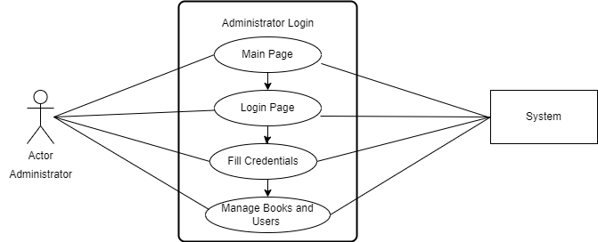

Figure 1: Use Case Diagram of Administrator Login

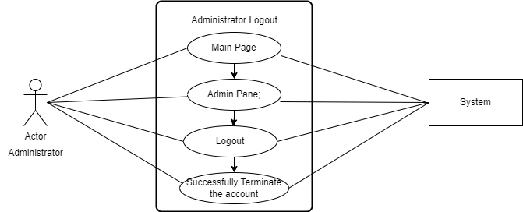

Figure 2: Use Case Diagram of Administrator Logout

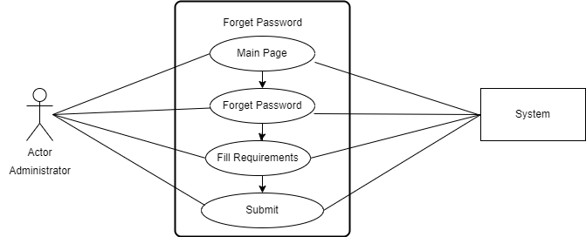

Figure 3: Use Case Diagram of Administrator Forget Password



Open the app

<<include>>

Sign up

Client

<<include>>

Fill Registration form

Figure 4: Use Case Diagram of User Sign up

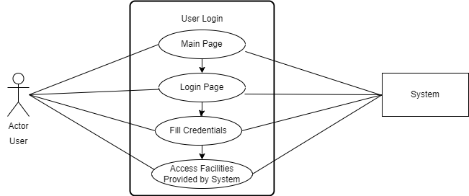

Figure 5: Use Case Diagram of User Login

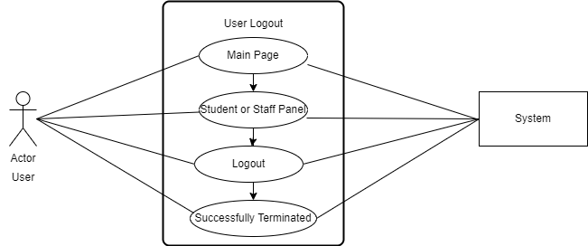

Figure 6: Use Case Diagram of User Logout



Login Panel

<<include>>

Forget Password

Client

<<include>>

Fill Requirement

<<include>>

Submit

Figure 7: Use Case Diagram of User Forget Password

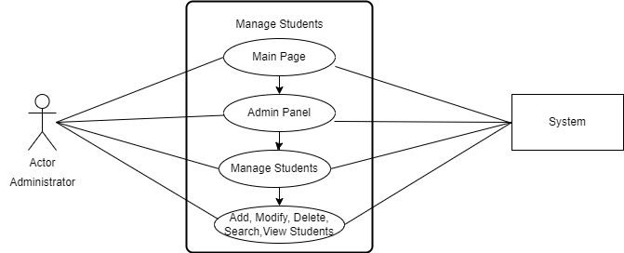

Figure 8: Use Case Diagram of Administrator Manage Students

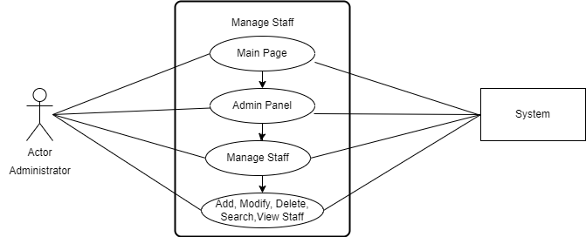

Figure 9: Use Case Diagram of Administrator Manage Staff

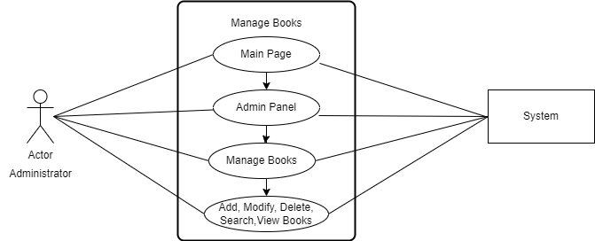

Figure 10: Use Case Diagram of Administrator Manage Books

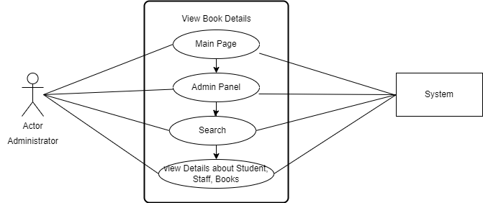

Figure 11: Use Case Diagram of Administrator View Details

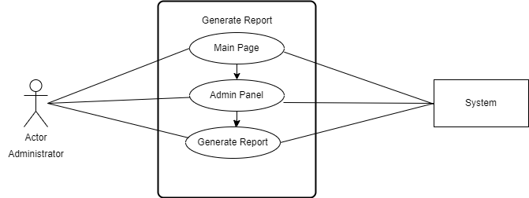

Figure 12: Use Case Diagram of Administrator Generate Report

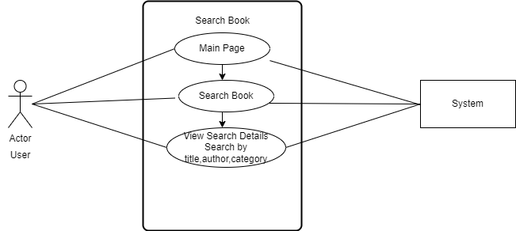

Figure 12: Use Case Diagram of User Search Book

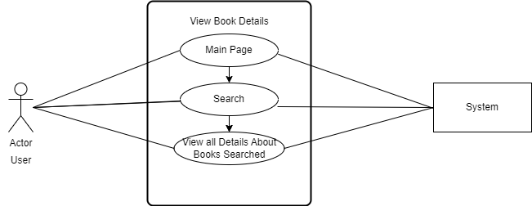

Figure 13: Use Case Diagram of User View Book Details

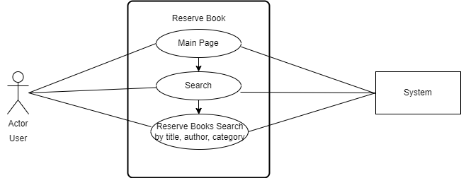

Figure 14: Use Case Diagram of User Reserve Book

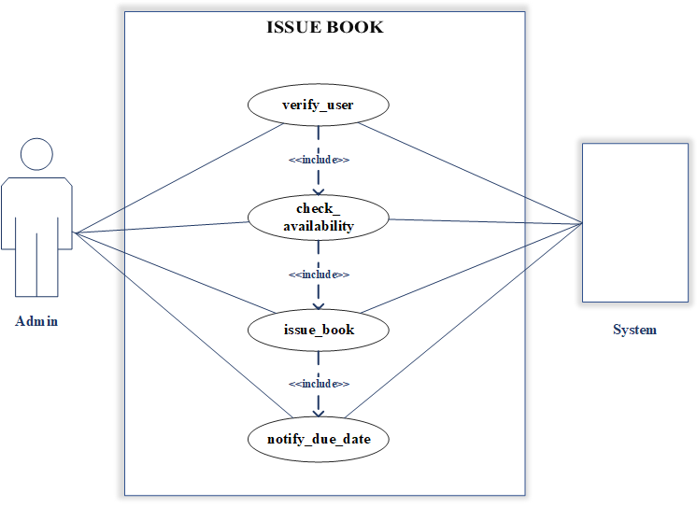

Figure 14: Use Case Diagram of Admin Issue Book

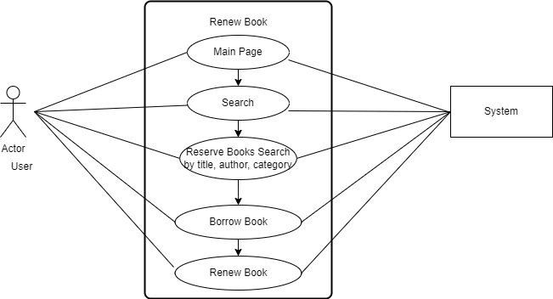

Figure 15: Use Case Diagram of User Renew Book

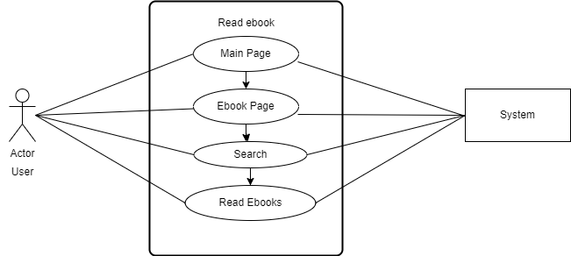

Figure 16: Use Case Diagram of User Read eBook

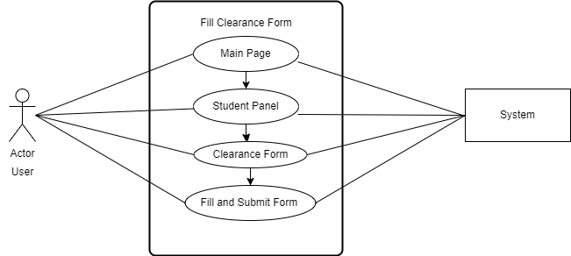

Figure 17: Use Case Diagram of User Clearance Form

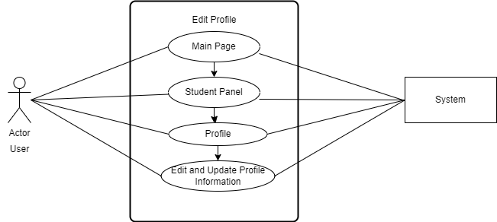

Figure 18: Use Case Diagram of Edit Profile

**CHAPTER 3**

# DESIGN

## 3.1 DESIGN

Methods and approaches differ depending on what you are developing but whether that involves processes in the healthcare sector or product development at a company we can say with certainty that design will help you to find new solutions**.**

## 3.2 Class Diagram

* 1. A class diagram models the static structure of a system. It shows relationships between classes, objects, attributes, and operations. Classes represent an abstraction of entities with common characteristics. Associations represent the relationships between classes. Classes with rectangles divided into compartments. Place the name of the class in the first partition (centered, bolded, and capitalized), list the attributes in the second partition (left-aligned, not bolded, and lowercase), and write operations into the third.

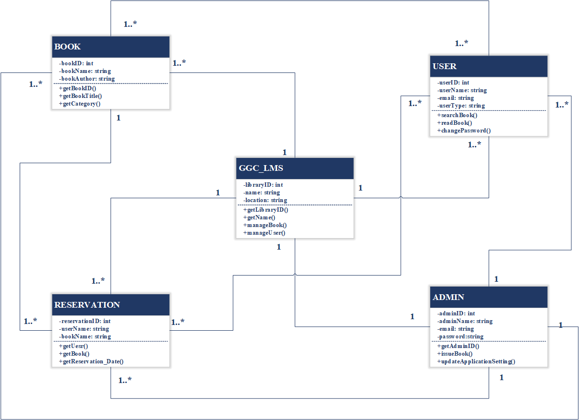

Figure 18: Class Diagram for Library Management System

## 3.3 Sequence Diagram

A Sequence diagram is an [interaction diagram t](https://en.wikipedia.org/wiki/Interaction_diagram)hat shows how objects operate with one another and in what order. It is a construct of a chart. Sequence diagram shows object interactions arranged in time sequence. It depicts the objects and classes involved in the scenario and the sequence of messages exchanged between the objects needed to carry out the functionality of the scenario. Sequence diagrams are typically associated with use case realizations in the Logical View of the system under development. Sequence diagrams are sometimes called event diagrams or event scenarios. A collaboration diagram, also called a communication diagram or interaction diagram, is an illustration of the relationships and interactions among software objects in the Unified Modeling Language (UML)

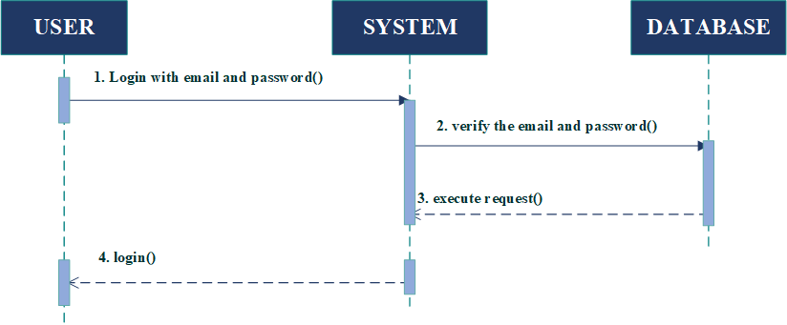

Figure 19: Sequence Diagram of Administrator Login

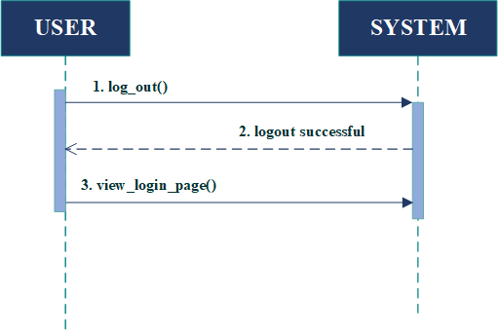

Figure 20: Sequence Diagram of Administrator Logout

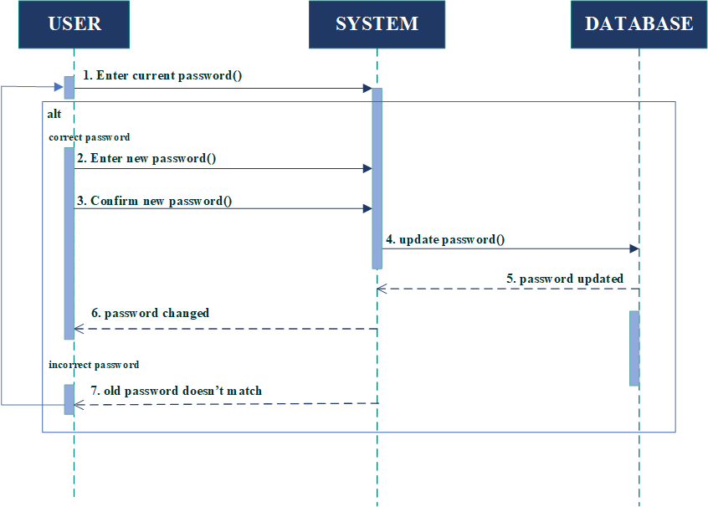

Figure 21: Sequence Diagram of Administrator change password

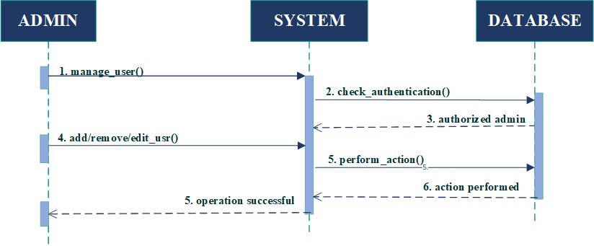Figure 22: Sequence Diagram of Manage User

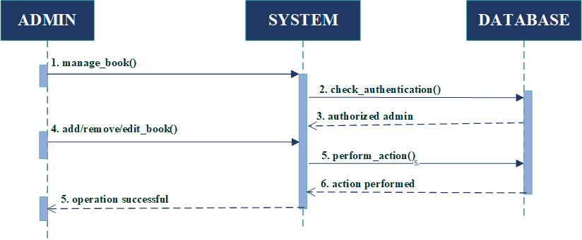

Figure 23: Sequence Diagram of Manage Book

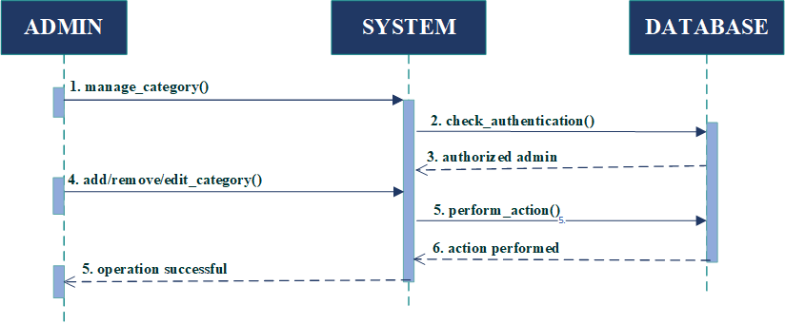

Figure 24: Sequence Diagram of Manage Category

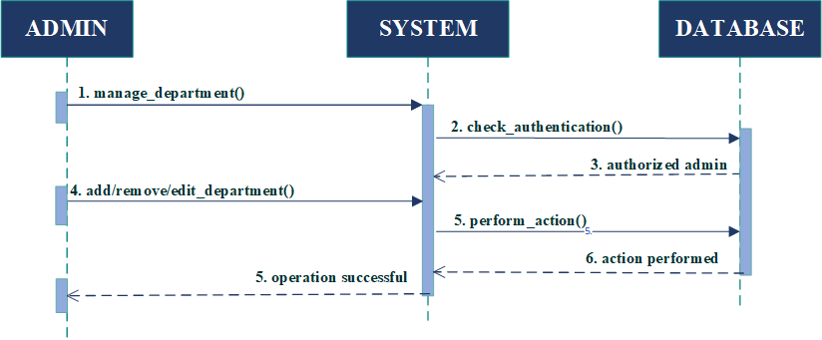

Figure 25: Sequence Diagram of Manage Department

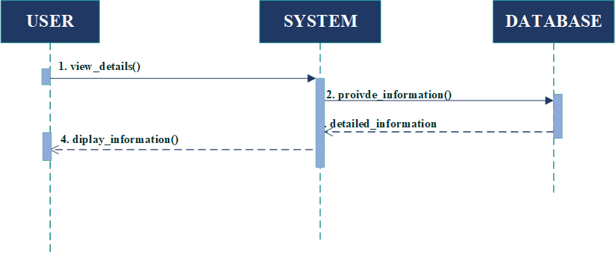

Figure 26: Sequence Diagram of View Details

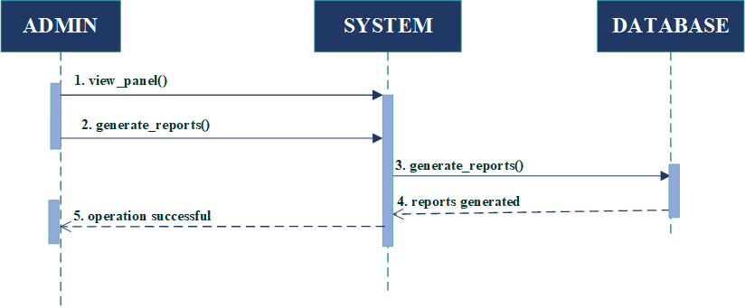

Figure 27: Sequence Diagram of Generate Report

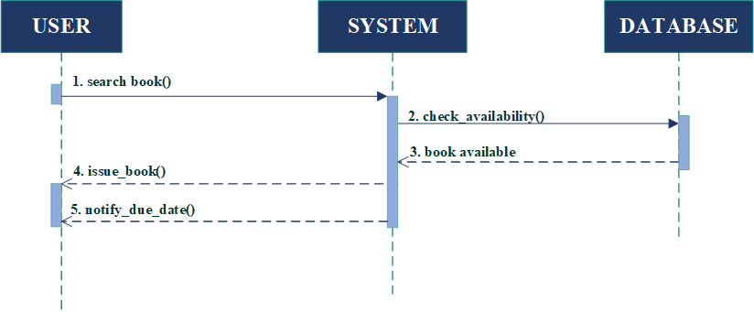

Figure 28: Sequence Diagram of Issue Book



Figure 29: Sequence Diagram of User Login



Figure 30: Sequence Diagram of User Logout



Figure 31: Sequence Diagram of Change Password

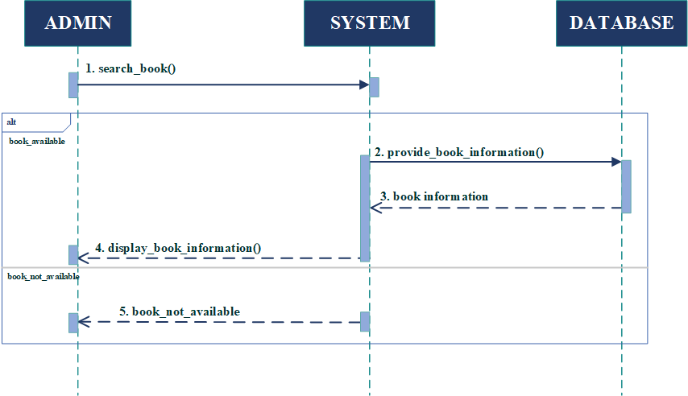

Figure 32: Sequence Diagram of Search Book



Figure 33: Sequence Diagram of User View Details

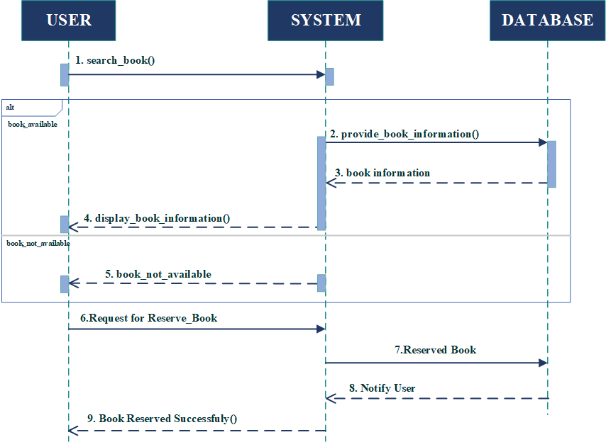

Figure 34: Sequence Diagram of Reserve Book

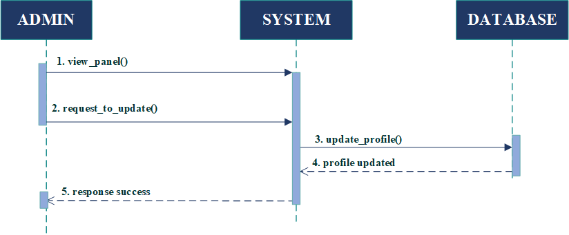

Figure 35: Sequence Diagram of Edit Profile

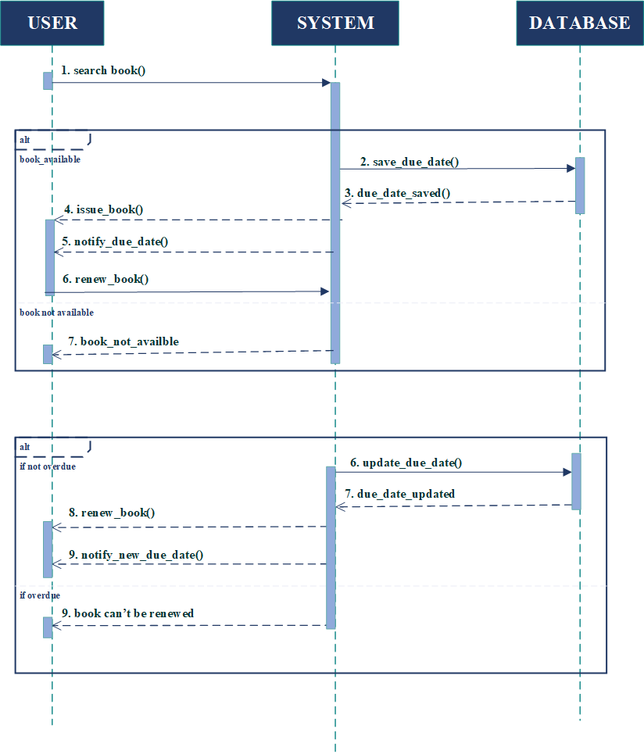 Figure 36: Sequence Diagram of Renew Book

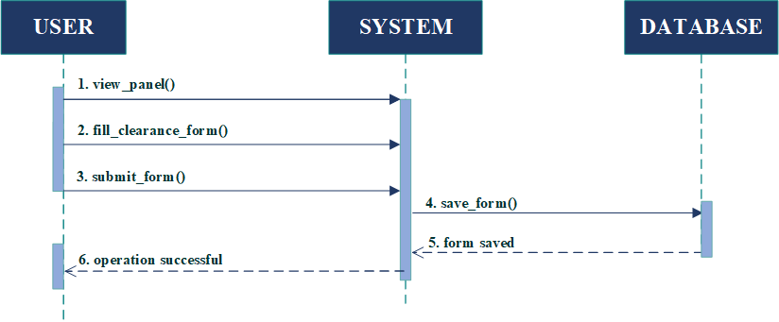

Figure 37: Sequence Diagram of Clearance Form

## 3.4 Collaboration Diagram

A collaboration diagram resembles a flowchart that portrays the roles, functionality and behavior of individual objects as well as the overall operation of the system in real time. Objects are shown as rectangles with naming labels inside. These labels are preceded by colons and may be underlined. The relationships between the objects are shown as lines connecting the rectangles. The messages between objects are shown as arrows connecting the relevant rectangles along with labels that define

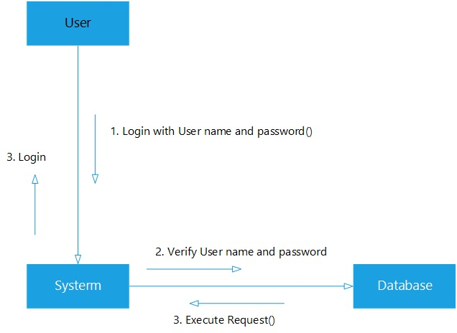

Figure 38: Collaboration Diagram of Administrator Login

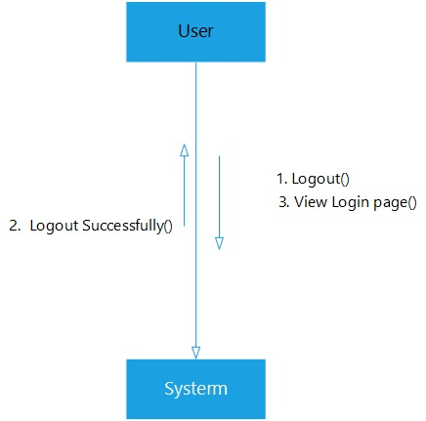

Figure 39: Collaboration Diagram of Administrator Logout

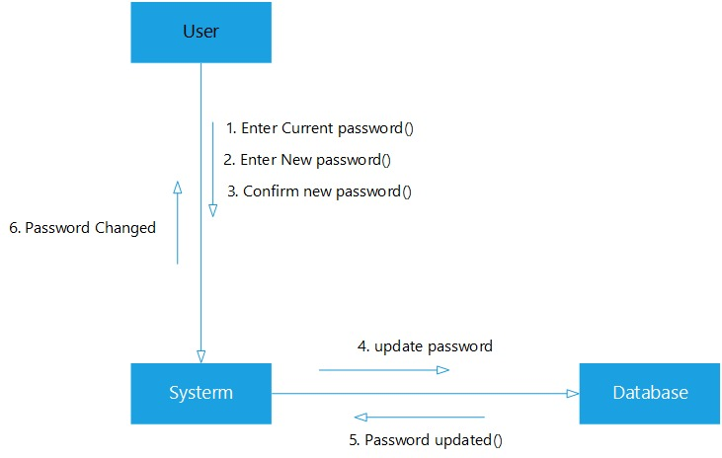

Figure 40: Collaboration Diagram of Administrator change password

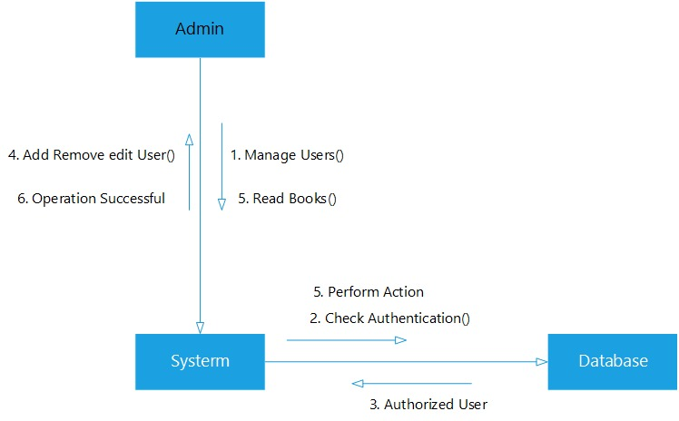

Figure 41: Collaboration Diagram of Manage User

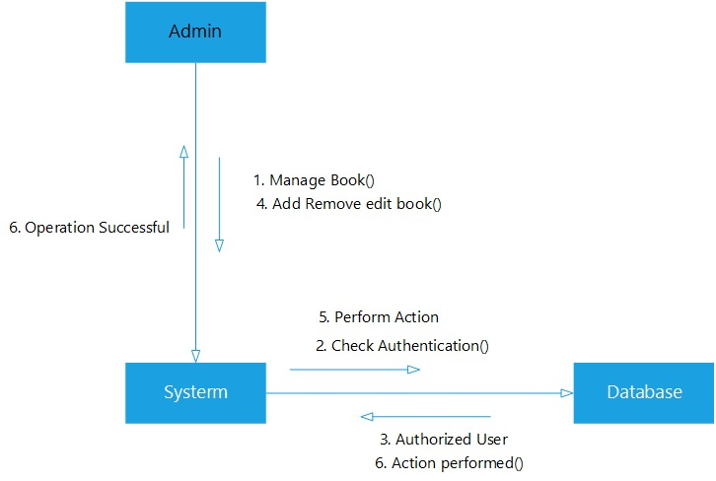

Figure 42: Collaboration Diagram of Manage Book

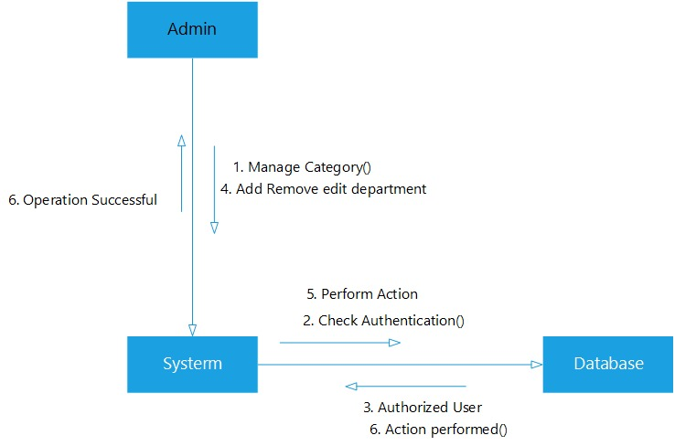

Figure 43: Collaboration Diagram of Manage Category

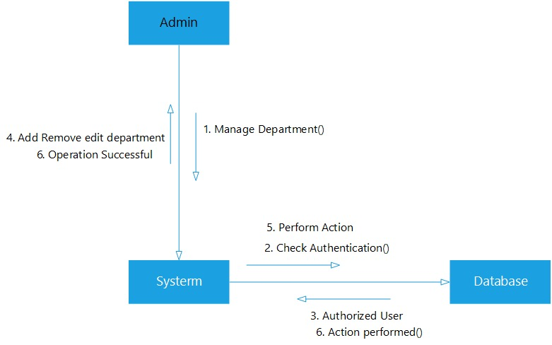

Figure 44: Collaboration Diagram of Manage Department

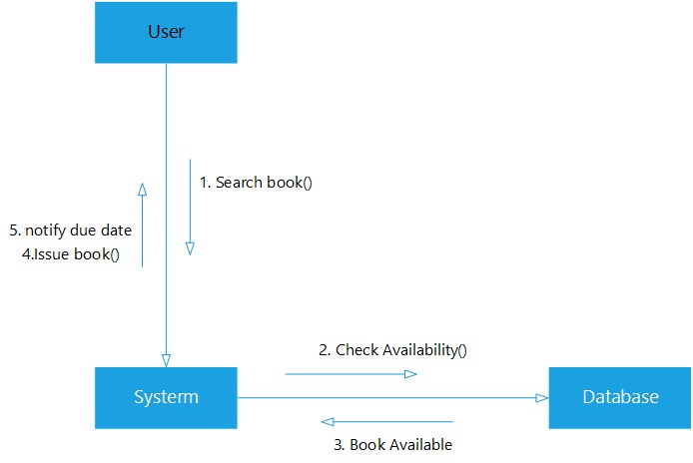

Figure 45: Collaboration Diagram of Issue Book

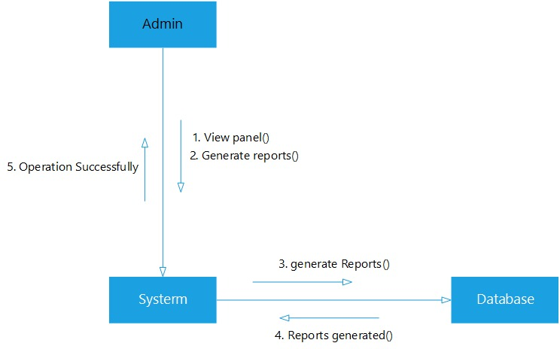

Figure 46: Collaboration Diagram of Generate Report



Figure 47: Collaboration Diagram of User Login



Figure 48: Collaboration Diagram of User Logout



**Figure 31: Collaboration Diagram of Change Password**

Figure 49: Collaboration Diagram of Change Password

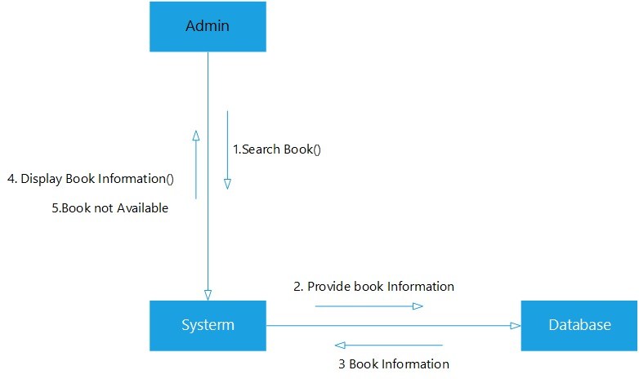 Figure 49: Collaboration Diagram of User Search Book

Figure 50: Collaboration Diagram of Search Book

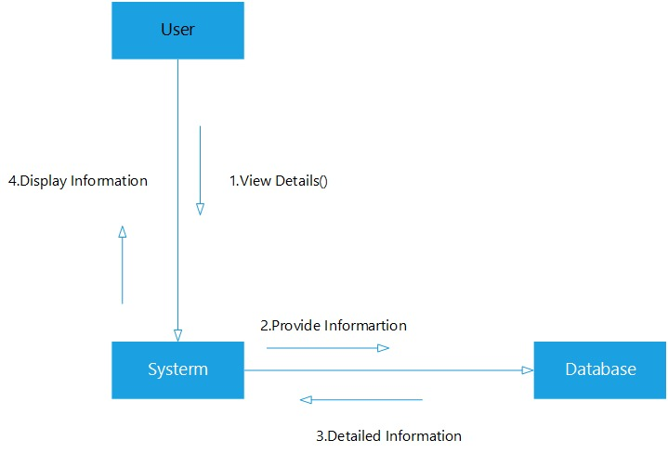

Figure 51: Collaboration Diagram of View Details

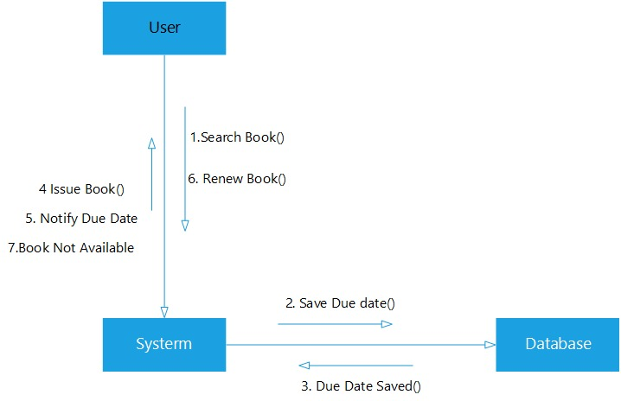

Figure 52: Collaboration Diagram of Renew Book

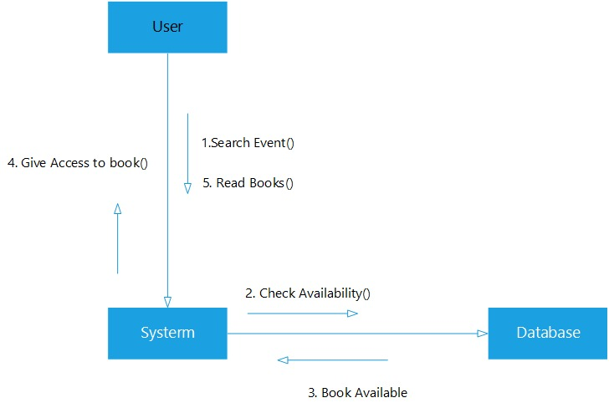

Figure 53: Collaboration Diagram of Read E-Book

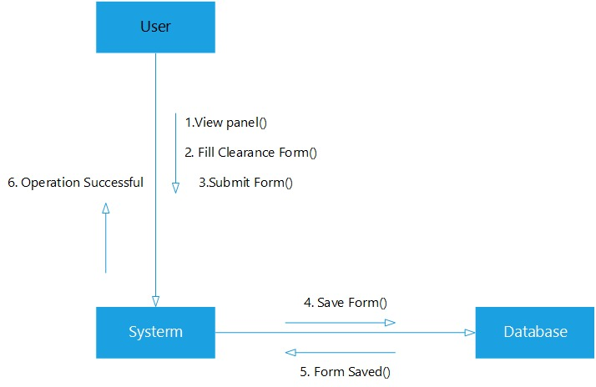

Figure 54: Collaboration Diagram of Clearance Form

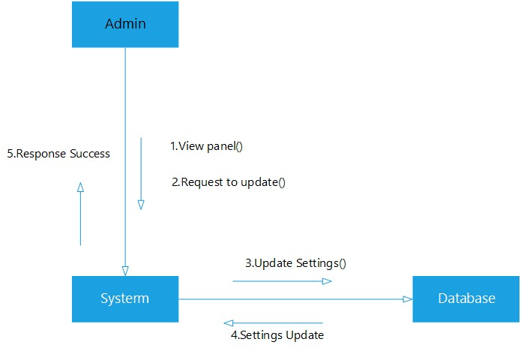

Figure 55: Collaboration Diagram of Edit Profile

**CHAPTER 4**

# TESTING

## 4.1 Testing

Testing is the process of evaluating a system or its component(s) with the intent to find whether it satisfies the specified requirements or not. In simple words, testing is executing a system in order to identify any gaps, errors, or missing requirements in contrary to the actual requirements.

Table : Testing Admin Login

|  |  |
| --- | --- |
| **Test Engineer:** | Shahzaib Afzal |
| **Test Case ID:** | TC-1 |
| **Related UC/FR/NFR** | UC-01 |
| **Date:** | 05-09-2023 |
| **Purpose:** | To Login |
| **Pre-Req.:** | Login as Administrator |
| **Test Data:** | Administrator login as their own Username or Password |
| **Steps:** | * Steps to carry out the test. * Visit Login Page * Enter email and password * Click on login Logged in Successfully |
| **Status:** | Pass |

Table : Testing Admin Logout

|  |  |
| --- | --- |
| **Test Engineer:** | Nouman Aziz |
| **Test Case ID:** | TC-2 |
| **Related UC/FR/NFR** | UC-02 |
| **Date:** | 05-09-2023 |
| **Purpose:** | To logout from account |
| **Pre-Req.:** | Logged out from account |
| **Test Data:** | Back to login page |
| **Steps:** | Steps to carry out the test.   * Login * Click on logout Successfully Logged out |
| **Status:** | Pass |

Table :Testing Admin Change Password

|  |  |
| --- | --- |
| **Test Engineer:** | Shahzaib Afzal |
| **Test Case ID:** | TC-9 |
| **Related UC/FR/NFR** | UC-09 |
| **Date:** | 00-12-2023 |
| **Purpose:** | Change Password |
| **Pre-Req.:** | Login as |
| **Test Data:** | Administrator logged in using his username and password |
| **Steps:** | Steps to carry out the test.   * Visit edit user section * Click “Change Password” option * Password Changed successfully |
| **Status** | Pass |

Table : Testing Manage Students

|  |  |
| --- | --- |
| **Test Engineer:** | Shahzaib Afzal |
| **Test Case ID:** | TC-1 |
| **Related UC/FR/NFR** | UC-01 |
| **Date:** | 06-09-2023 |
| **Purpose:** | To store students’ details |
| **Pre-Req.:** | To manage students as Administrator |
| **Test Data:** | Administrator sign in as their own account to enter data |
| **Steps:** | Steps to carry out the test.   * Visit admin panel. * Add students. * Update students. * Delete students. * Students managed Successfully |
| **Status:** | Pass |

Table : Testing Manage Staff

|  |  |
| --- | --- |
| **Test Engineer:** | Mehran Ali |
| **Test Case ID:** | TC-2 |
| **Related UC/FR/NFR** | UC-02 |
| **Date:** | 06-09-2023 |
| **Purpose:** | To store staff details |
| **Pre-Req.:** | To manage staff as Administrator |
| **Test Data:** | Administrator sign in as their own account to enter data |
| **Steps:** | Steps to carry out the test.   * Visit admin panel. * Add students. * Update students. * Delete students. * Students managed Successfully |
| **Status:** | Pass |

Table : Testing Books Management

|  |  |
| --- | --- |
| **Test Engineer:** | Mehran Ali |
| **Test Case ID:** | TC-5 |
| **Related UC/FR/NFR** | UC-05 |
| **Date:** | 06-09-2023 |
| **Purpose:** | To store Books details |
| **Pre-Req.:** | To manage books as administrator |
| **Test Data:** | Administrator sign in as their own account to enter data |
| **Steps:** | Steps to carry out the test.   * Admin enter to the admin panel * Admin can add book * Admin can update book * Admin can delete book * Admin can modify book details * Books are managed Successfully |
| **Status:** | Pass |

Table :Testing Generate Report

|  |  |
| --- | --- |
| **Test Engineer:** | Mehran Ali |
| **Test Case ID:** | TC-6 |
| **Related UC/FR/NFR** | UC-06 |
| **Date:** | 07-09-2023 |
| **Purpose:** | To Generate Report |
| **Pre-Req.:** | Generate report as administrator |
| **Test Data:** | Administrator sign in as their own account to create monthly report |
| **Steps:** | Steps to Carry out the test.   * Admin enter to the admin panel * Click on “Generate Report” Button * Reports successfully generated |
| **Status:** | Pass |

Table : Testing Student Login

|  |  |
| --- | --- |
| **Test Engineer:** | Shahzaib Afzal |
| **Test Case ID:** | TC-1 |
| **Related UC/FR/NFR** | UC-01 |
| **Date:** | 07-09-2023 |
| **Purpose:** | To Login |
| **Pre-Req.:** | Login as Student |
| **Test Data:** | Student login as their own Username or Password |
| **Steps:** | Steps to carry out the test.   * Visit Login Page * Enter email and password * Click on login Logged in Successfully |
| **Status:** | Pass |

Table : Testing Student Logout

|  |  |
| --- | --- |
| **Test Engineer:** | Mehran Ali |
| **Test Case ID:** | TC-10 |
| **Related UC/FR/NFR** | UC-10 |
| **Date:** | 08-09-2023 |
| **Purpose:** | To logout from Student account |
| **Pre-Req.:** | Logged out from Student account |
| **Test Data:** | Back to login page |
| **Steps:** | * Steps to carry out the test. * Login * Click on logout * Student successfully Logged out |
| **Status:** | Pass |

Table : Testing Student Change Password

|  |  |
| --- | --- |
| **Test Engineer:** | Mehran Ali |
| **Test Case ID:** | TC-11 |
| **Related UC/FR/NFR** | UC-11 |
| **Date:** | 08-09-2023 |
| **Purpose:** | To change student password |
| **Pre-Req.:** | Change student password |
| **Test Data:** | Student use their own username and password |
| **Steps:** | Steps to carry out the test.   * Click on “Forget Password” Option * Enter Email ID * Change Password * Paasword Changed Successfully |
| **Status:** | Pass |

Table :Testing Search Books

|  |  |
| --- | --- |
| **Test Engineer:** | Nouman Aziz |
| **Test Case ID:** | TC-11 |
| **Related UC/FR/NFR** | UC-11 |
| **Date:** | 08-09-2023 |
| **Purpose:** | To search books |
| **Pre-Req.:** | Search Books |
| **Test Data:** | Client use their own username and password |
| **Steps:** | Steps to carry out the test.   * Click on “Search Bar” Option * Search book by author, title, name * Click on “Search” Button * Searched Book appeared Successfully |
| **Status:** | Pass |

Table : Testing View Book Detail

|  |  |
| --- | --- |
| **Test Engineer:** | Nouman Aziz |
| **Test Case ID:** | TC-11 |
| **Related UC/FR/NFR** | UC-11 |
| **Date:** | 08-09-2023 |
| **Purpose:** | To view book details |
| **Pre-Req.:** | View Books Detail |
| **Test Data:** | Client use their own username and password |
| **Steps:** | Steps to carry out the test.   * Click on “Search Bar” Option to search book * Select book for details * Got Details Successfully |
| **Status:** | Pass |

Table : Testing Reserve Book

|  |  |
| --- | --- |
| **Test Engineer:** | Nouman Aziz |
| **Test Case ID:** | TC-11 |
| **Related UC/FR/NFR** | UC-11 |
| **Date:** | 08-09-2023 |
| **Purpose:** | To reserve books |
| **Pre-Req.:** | Reserve Books |
| **Test Data:** | Client use their own username and password |
| **Steps:** | Steps to carry out the test.   * Click on “Search Bar” Option to search books * Select the book required * Click on “Reserve Book” Option * Book Reserved Successfully |
| **Status:** | Pass |

## 

Table : Testing Borrow Book

|  |  |
| --- | --- |
| **Test Engineer:** | Nouman Aziz |
| **Test Case ID:** | TC-11 |
| **Related UC/FR/NFR** | UC-11 |
| **Date:** | 08-09-2023 |
| **Purpose:** | To borrow book |
| **Pre-Req.:** | Borrow Books |
| **Test Data:** | Client use their own username and password |
| **Steps:** | Steps to carry out the test.   * Click on “Search Bar” Option to search books * Select the book that required * Click on “Borrow Book” Button * Book Borrowed Successfully |
| **Status:** | Pass |

## 

Table : Testing Renew Books

|  |  |
| --- | --- |
| **Test Engineer:** | Shahzaib Afzal |
| **Test Case ID:** | TC-11 |
| **Related UC/FR/NFR** | UC-11 |
| **Date:** | 09-09-2023 |
| **Purpose:** | To renew books |
| **Pre-Req.:** | Renew Books |
| **Test Data:** | Client use their own username and password |
| **Steps:** | Steps to carry out the test.   * Select the book that you want to renew * Click on “Renew Book” Option * Books Renewed Successfully |
| **Status:** | Pass |
| **Purpose:** | To change student password |
| **Pre-Req.:** | Change student password |
| **Test Data:** | Student use their own username and password |

**CHAPTER 5**

# CONCLUSION & FUTUREWOR

## 5.1 Future Work:

* **Expansion of digital collections:**

Continuously adding new and diverse digital resources, including e-books, e-journals, multimedia content, and open educational resources, to meet the evolving needs of users.

* + - **Mobile – friendly interfaces and services:**

Optimizing digital library systems for mobile devices, enabling users to access resources, including licensing, access, and usage tracking.

* + - **Integration with learning management systems:**

Connecting digital library systems with LMS platforms to provide seamless access to library resources and services for students and educators.

* + - **Integration of Artificial Intelligence and Machine Learning:**

Utilizing AI and ML technologies to improve search and recommendation algorithms, automate routine tasks, and provide more advanced analytics for library management.

* **Support for emerging technologies:**

Exploring the integration of technologies such as Virtual reality (VR), augmented reality (AR) and blockchain to enhance the discovery, access and use of digital library resources.

* **Enhanced metadata management:**

Developing more efficient and automated processes for metadata creation, enrichment, and maintenance to ensure accurate and comprehensive resource discovery.

## 5.2 Conclusion:

Library Management System offer several advantages over traditional library systems. They provide a practical solution to the existing issues of the traditional library system, such as slow and inefficient manual processes. They also offer improved and innovative services, converting librarians into cybrarians through automation of routine tasks. Library Systems are accessible from anywhere, at any time, and can be used to connect a digital library resource to a related resource. They can make digital library materials accessible to disparate communities.

In conclusion, digital library management systems are a necessary tool for organizations to remain relevant in a knowledge economy. They offer several advantages over traditional library systems, but also come with challenges that need to be addressed.

**CHAPTER 6**

# USER MANUAL

**Login**

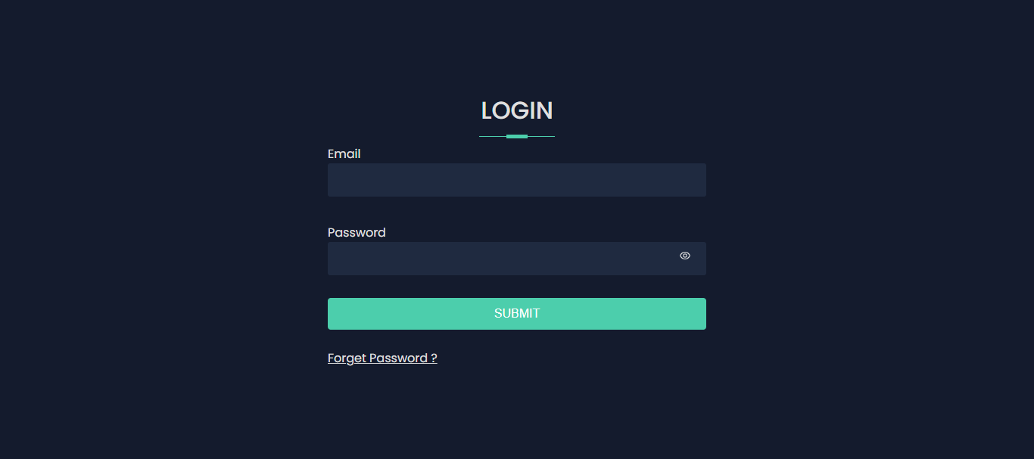

**Step 1:** Open Website

**Step 2:** Click Login

**Change Password**

## 

**Step 1:** Open Website

**Step 2:** Open Login page then click on Forget Password

**Hero** **Section**

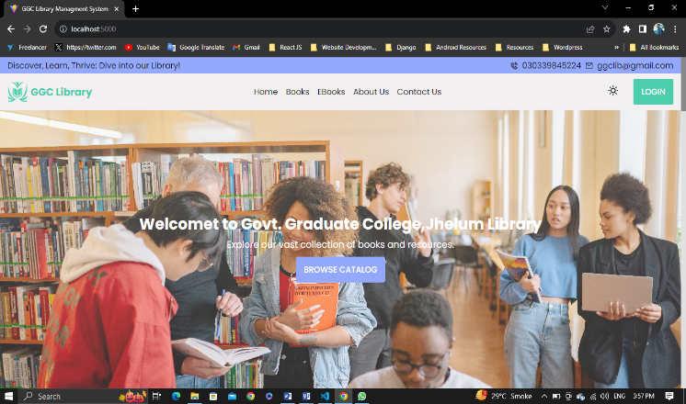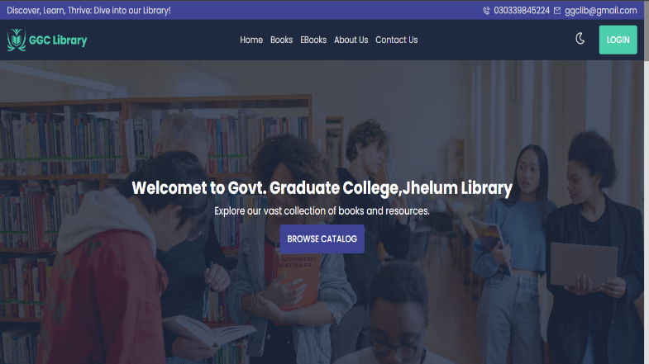

**Step 1:** Visit the Website of GCC LMS

**Step 2:** Login first if you are not Authorized

**Step 3:** Click on Home Page to view the hero section

**Step 4:** Click on Theme mode option to change the theme

## 

**Home** **Page**

## 

## 

**Step 1:** Visit the Website of GCC LMS

**Step 2:** Login first if you are not Authorized

**Step 3:** Click on Home Page and view the page

**Home page footer**

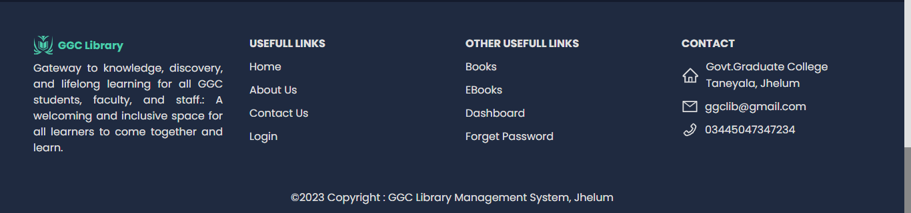

**Step 1**: Visit the Website of GCC LMS

**Step 2:** Login first if you are not Authorized

**Step 3:** Click on Home Page and scroll it down to use the footer options

**Book Page**

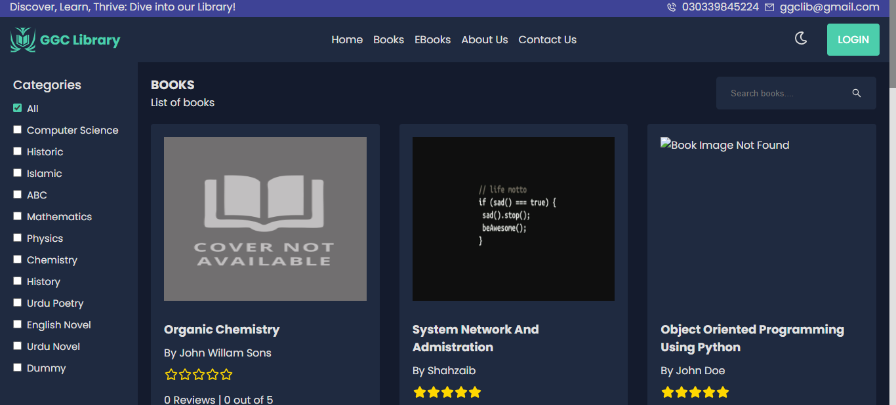

## 

## 

**Step 1:** Visit the Website of GCC LMS

**Step 2:** Login first if you are not Authorized

**Step 3:** Click on Book Page from navbar and Reserve, Borrow, and Renew books

**View Book Details**

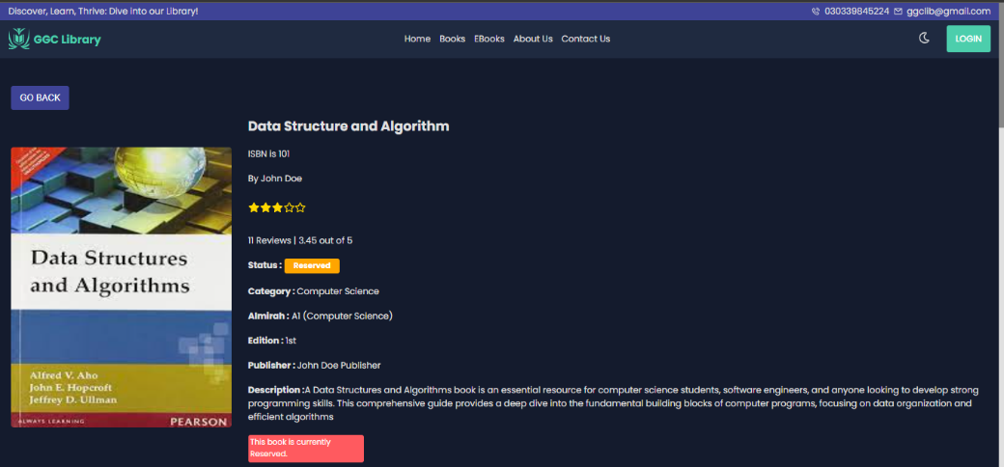

**Step 1:** Open the website of GCC LMS

**Step 2:** Enter Email and password for Login

**Step 3:** Click on Login button

**Step 4:** Click on Book Page from navbar

**Step 5:** Click on any book that you want to read and view its details successfully

**Reviews and Rating**

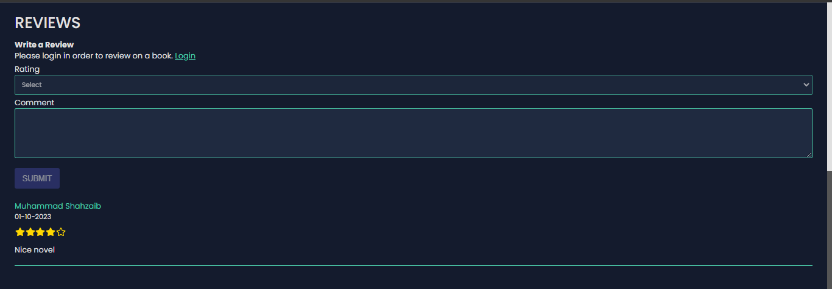

**Step 1**: Visit the Website of GCC LMS

**Step 2:** Login first if you are not Authorized

**Step 3:** Click on Book Page from navbar and give Review and Rating to any book

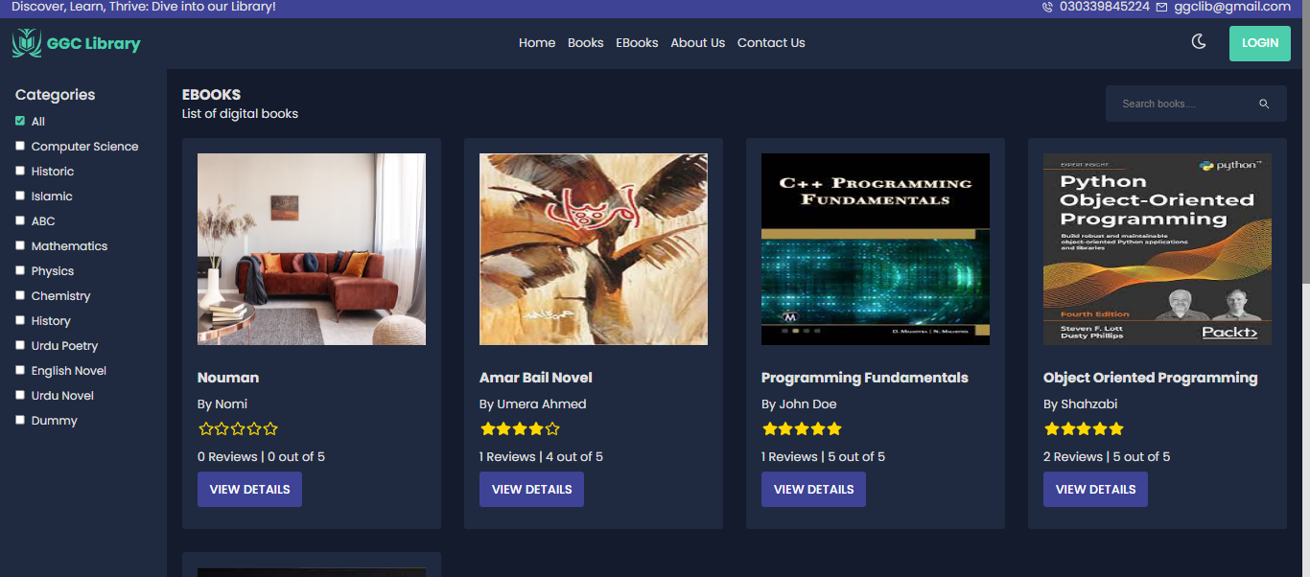**E-book Page**

**Step 1:** Open the website of GCC LMS

**Step 2:** Enter Email and password for Login

**Step 3:** Click on Login button

**Step 4:** Click on E-Book Page from navbar

**Step 5:** Click on any book that you want to read and view its details successfully

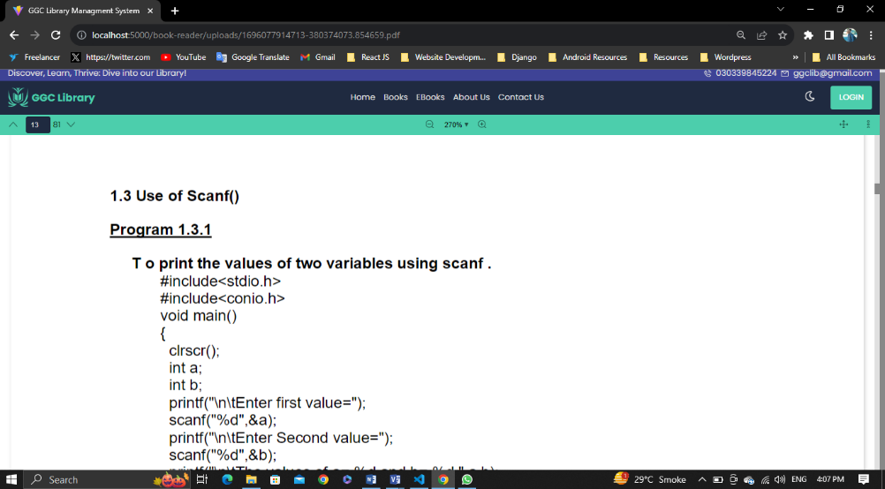**Read E-Book**

## 

**Step 1**: Visit the Website of GCC LMS

**Step 2:** Login first if you are not Authorized

**Step 3:** Click on E-Book Page from navbar and Open any book that you want to read in pdf format

**About Us Page**

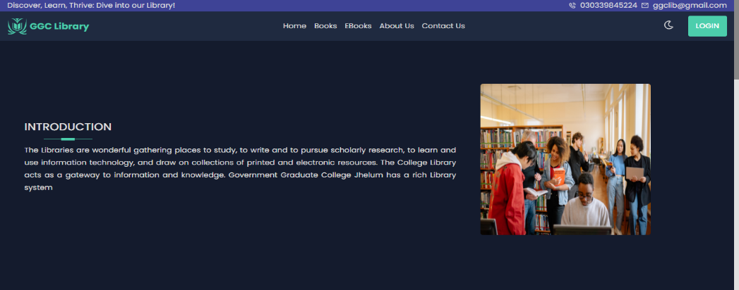

## 

**Step 1**: Visit the Website of GCC LMS

**Step 2:** Login first if you are not Authorized

**Step 3:** Click on About Us page from navbar, then visit and read more to know us

**Contact Us Page**

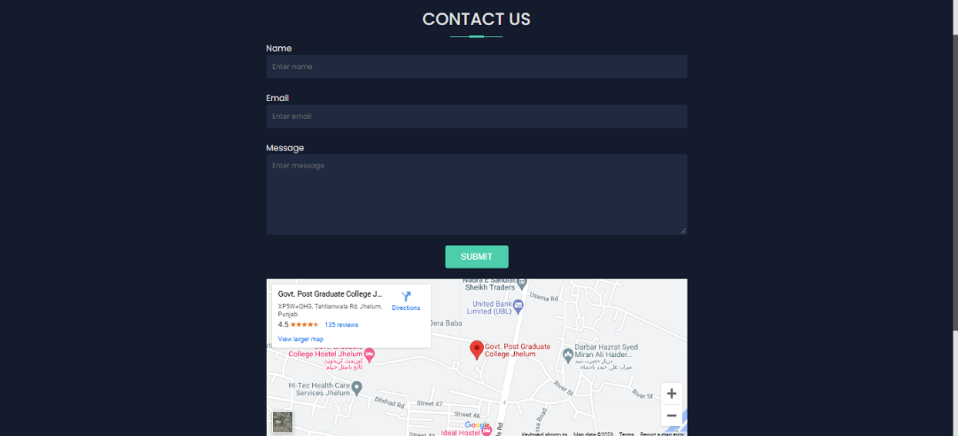

**Step 1:** Open the website of GCC LMS

**Step 2:** Enter Email and password for Login

**Step 3:** Click on Login button

**Step 4:** Click on Contact Us Page from navbar

**Step 5:** Fill the requirements to contact us

**Step 6:** Click on Submit button

**Admin Dashboard**

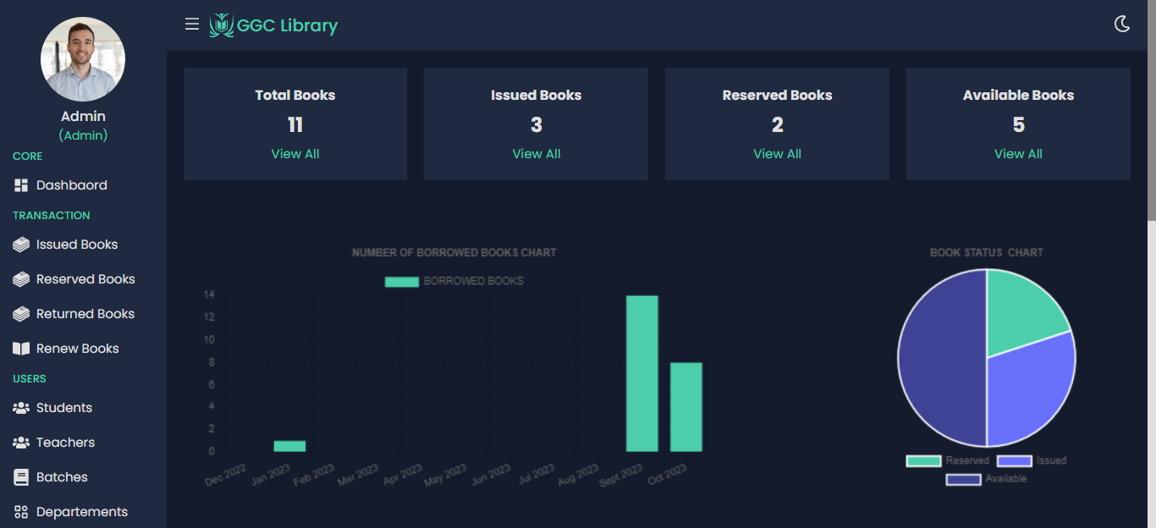

**Step 1:** Open the website of GCC LMS

**Step 2:** Enter Email and password for Login

**Step 3:** Click on Login button

**Step 4:** Click on hamburger Icon from navbar

**Step 5:** Click on Admin Dashboard from sidebar

**Manage Book Interface**

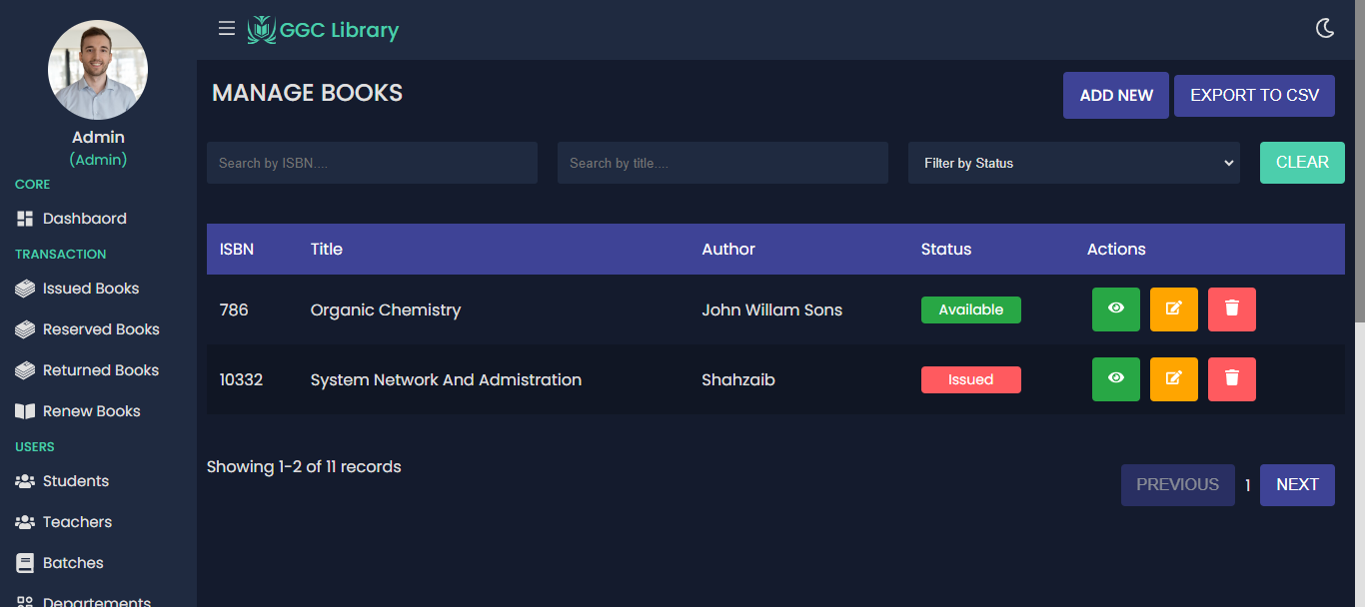

**Step 1:** Open the website of GCC LMS

**Step 2:** Enter Email and password for Login

**Step 3:** Click on Login button

**Step 4:** Click on hamburger Icon from navbar

**Step 5:** Click on Admin Dashboard from sidebar

**Step 6:** Select the Manage Book option from sidebar and perform operations

**Manage Student Interface**

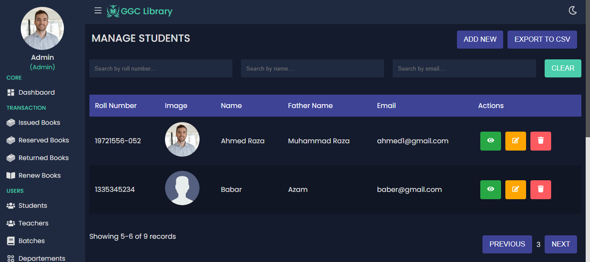

**Step 1:** Open the website of GCC LMS

**Step 2:** Enter Email and password for Login

**Step 3:** Click on Login button

**Step 4:** Click on hamburger Icon from navbar

**Step 5:** Click on Admin Dashboard from sidebar

**Step 6:** Select the Manage Student option from sidebar and perform operations

**Issue Book Interface**

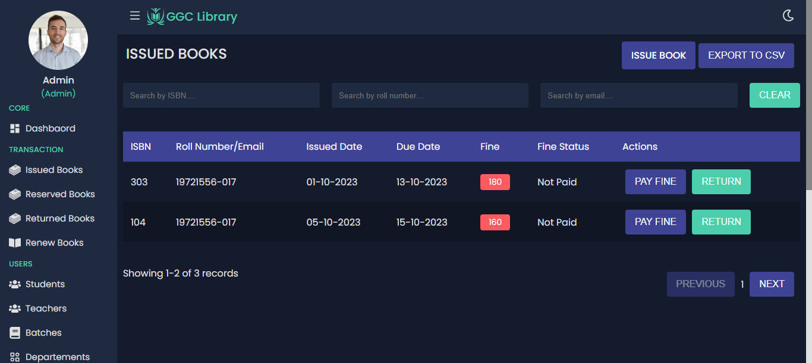

**Step 1:** Open the website of GCC LMS

**Step 2:** Enter Email and password for Login

**Step 3:** Click on Login button

**Step 4:** Click on hamburger Icon from navbar

**Step 5:** Click on Admin Dashboard from sidebar

**Step 6:** Select the Issue Book option from sidebar and perform operations

**User Dashboard Interface**

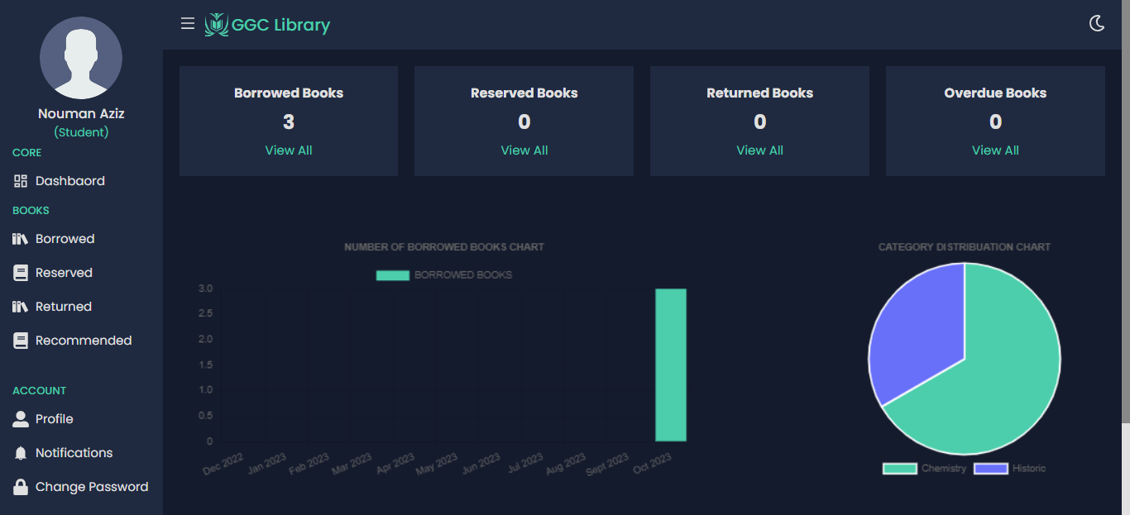

**Step 1:** Open the website of GCC LMS

**Step 2:** Enter Email and password for Login

**Step 3:** Click on Login button

**Step 4:** Click on hamburger Icon from navbar

**Step 5:** Click on User Dashboard from sidebar

**Step 6:** Visit the User Dashboard and perform operations

**User Profile Interface**

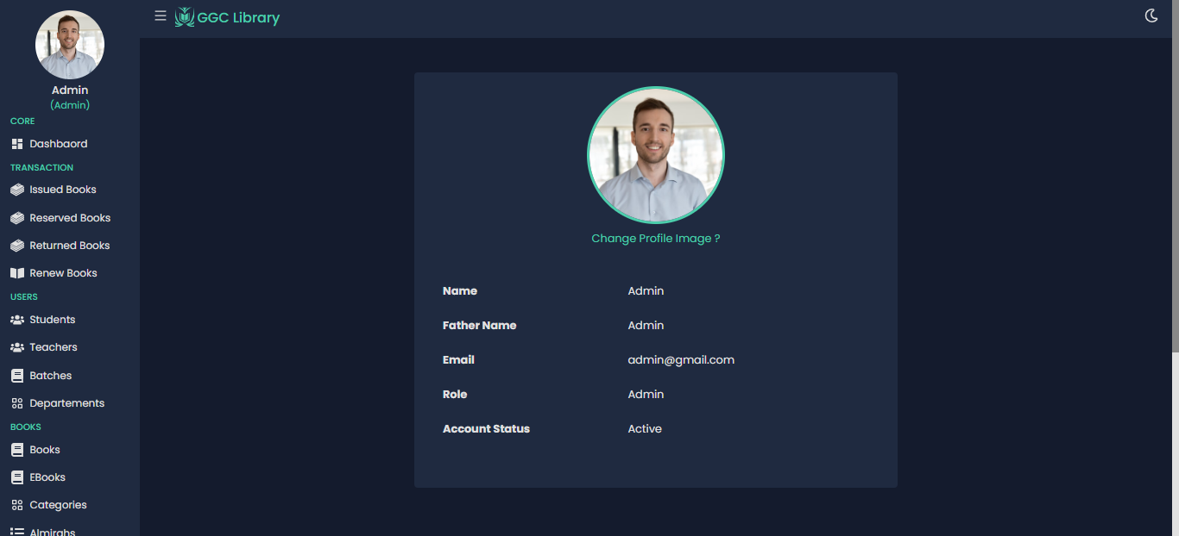

**Step 1:** Open the website of GCC LMS

**Step 2:** Enter Email and password for Login

**Step 3:** Click on Login button

**Step 4:** Click on hamburger Icon from navbar

**Step 5:** Click on User Profile from sidebar

**Step 6:** Visit and read the User Profile successfully

**Pay Fine Interface**

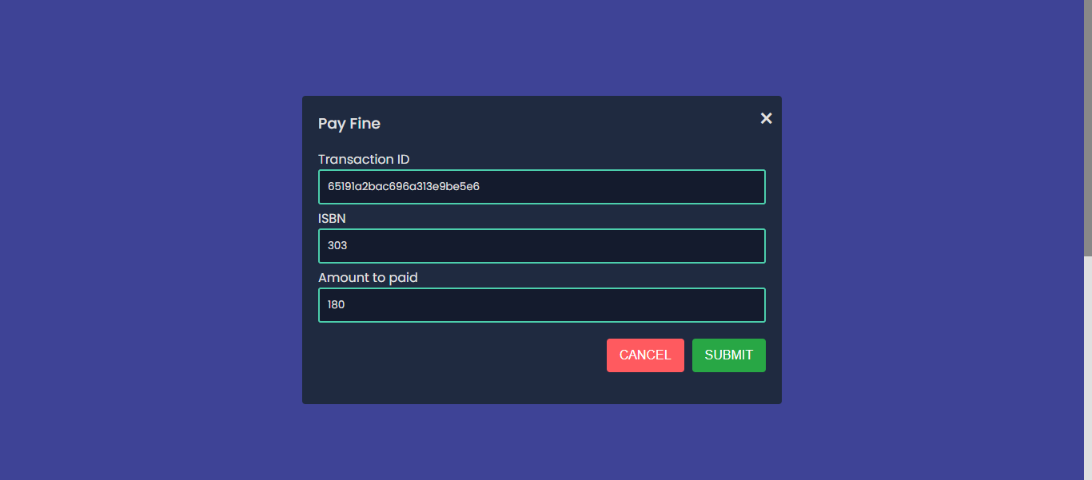

**Step 1:** Open the website of GCC LMS

**Step 2:** Enter Email and password for Login

**Step 3:** Click on Login button

**Step 4:** Click on Hamburger Icon from navbar

**Step 5:** Click and drag the Scroll Button

**Step 6:** Select the pay fine Option

**Step 7:** Fill the required information

**Step 8:** Click on SUBMIT Button

**Edit Profile Interface**

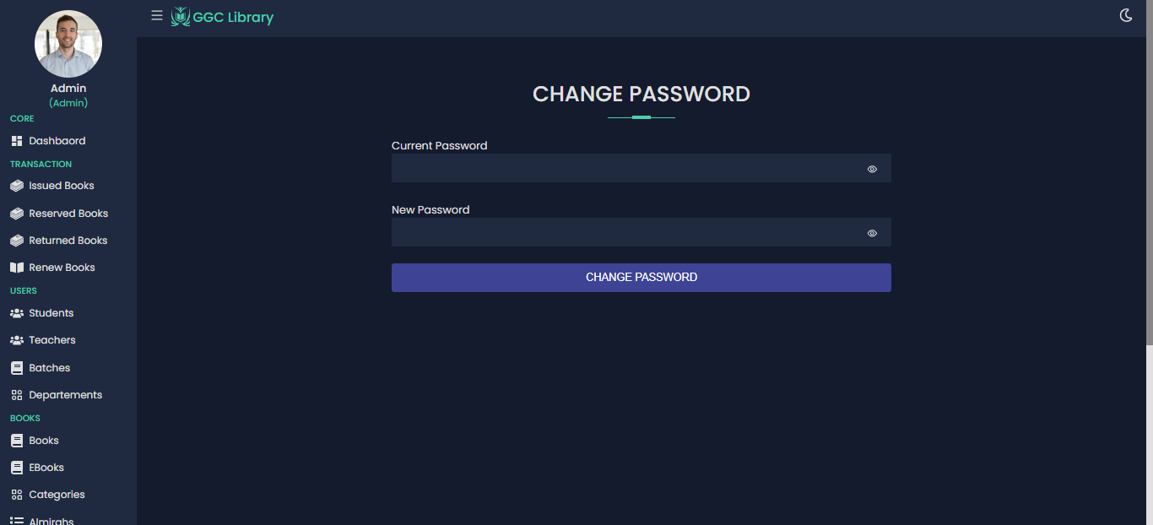

**Step 1:** Open the website of GCC LMS

**Step 2:** Enter Email and password for Login

**Step 3:** Click on Login button

**Step 4:** Click on Hamburger Icon from navbar

**Step 5:** Click on User Dashboard

**Step 6:** Click and drag the Scroll Button

**Step 7:** Select the Edit Profile Option

**Step 8:** Modify your Profile successfully

**Clearance Form Interface**

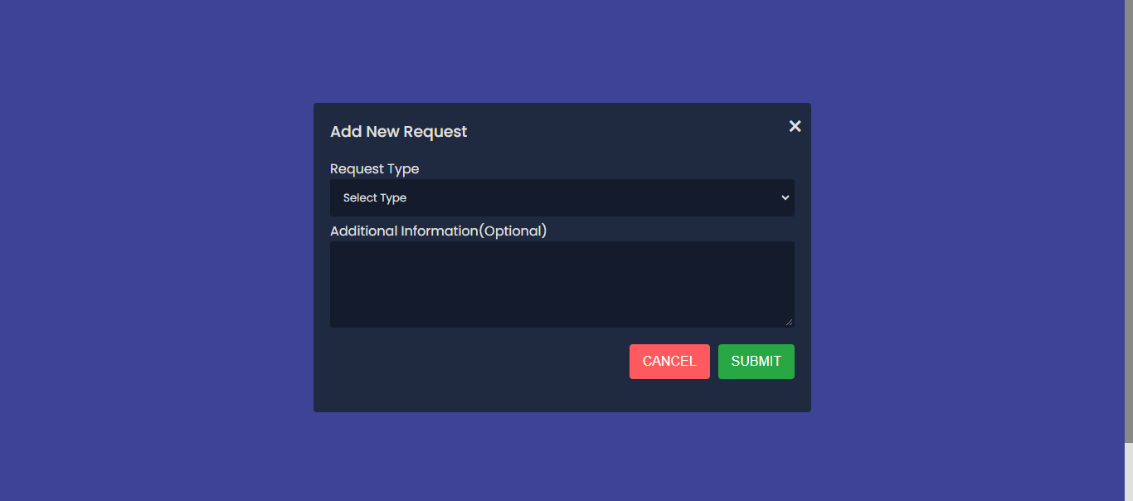

**Step 1:** Open the website of GCC LMS

**Step 2:** Enter Email and password for Login

**Step 3:** Click on Login button

**Step 4:** Click on Hamburger Icon from navbar

**Step 5:** Click on User Dashboard

**Step 6:** Click and drag the Scroll Button

**Step 7:** Select the Clearance form Option

**Step 8:** Fill the required information

**Step 9:** Click on SUBMIT Button

**Manage Clearance Request Interface**

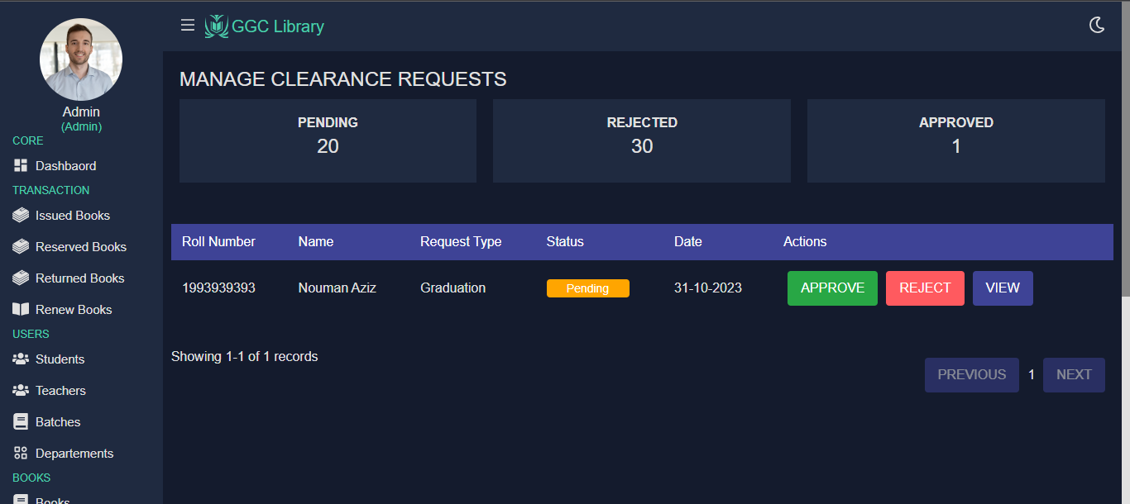

**Step 1:** Open the website of GCC LMS

**Step 2:** Enter Email and password for Login

**Step 3:** Click on Login button

**Step 4:** Click on Hamburger Icon from navbar

**Step 5:** Click on Admin Dashboard

**Step 6:** Click and drag the Scroll Button

**Step 7:** Select the Manage Clearance request Option

**Step 8:** View and proceed the operationsuccessfully

**Approved Clearance Request Interface**

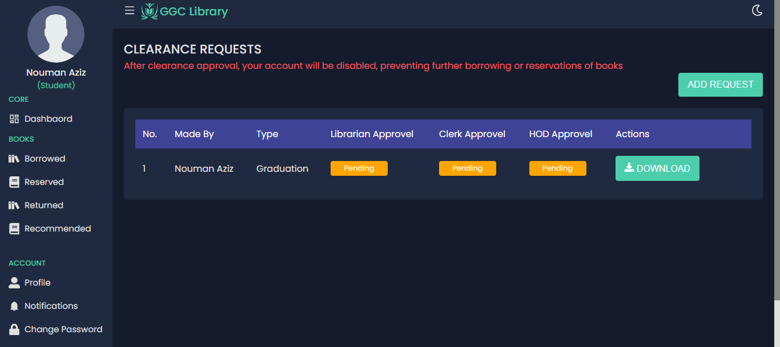

**Step 1:** Open the website of GCC LMS

**Step 2:** Enter Email and password for Login

**Step 3:** Click on Login button

**Step 4:** Click on Hamburger Icon from navbar

**Step 5:** Click on Admin Dashboard

**Step 6:** Click and drag the Scroll Button

**Step 7:** Select the Approved Clearance request Option

**Step 8:** View and proceed the operationsuccessfully

# REFERENCES

1. "Clifton Park Halfmoon Public Library," [Online]. Available: https://www.cphlibrary.org /
2. “Brookline Libraries,” [Online]. Available: <https://www.brooklinelibrary.org/>
3. “Public Library of Congress,” [Online]. Available: https://www.loc.gov/